光伏发电站工程项目用地控制指标

2015年12月2日发布 2016年1月1日实施

中华人民共和国国土资源部

目 次

1 基本规定 7
2 光伏发电站工程项目用地总体指标 8
3 光伏方阵用地指标 34
4 变电站及运行管理中心用地指标 36
5 集电线路用地指标 37
6 场内道路用地指标 38
附录A 直辖市、省会城市光伏阵列斜面日均辐射量参考值 39
附录B 计算实例 40
附加说明 编制单位和主要起草人员名单 65
附件 《光伏发电站工程项目用地控制指标》条文说明 66

光伏发电站工程项目用地控制指标

为落实建设项目用地标准控制制度，促进土地节约集约利用，依据《中华人民共和国土地管理法》、《国务院关于促进节约集约用地的通知》（国发[2008]3号）、《节约集约利用土地规定》（国土资源部令第61号）、《光伏发电站设计规范》（GB50797-2012）等法律、法规、技术规范，编制《光伏发电站工程项目用地控制指标》（以下简称本用地指标）。

1 基本规定

1.1 本用地指标适用于新建、改建和扩建地面光伏发电站工程项目。
1.2 光伏发电站工程项目建设，应遵循节约优先的原则，在综合考虑光能资源、场址、环境等建设条件的同时，应进行优化配置，合理利用土地。尽量利用未利用地，不占或少占农用地。
1.3 光伏发电站工程项目建设，应根据光伏发电行业发展的需要，在满足安全性和可靠性的同时，体现科学、合理和节约集约用地的原则。
1.4 本用地指标是光伏发电站工程项目可行性研究（初步设计）、用地审批、土地供应、供后监管、竣工验收等环节确定用地规模的依据和尺度。
1.5 编制光伏发电站工程项目可行性研究报告，应当按照本用地指标确定的总体规模和各功能分区规模进行规模核定。并在报告中对用地规模核定情况进行专篇说明。
1.6 审批光伏发电站工程项目用地，应当按照本用地指标确定的总用地规模和各功能分区用地规模进行核定。
1.7 核发光伏发电站工程项目土地划拨决定书和签订出让合同，应明确规定或约定建设项目用地总规模和各功能分区用地规模。
1.8 本用地指标分为总体指标和分项指标。采用总体指标时，光伏发电站工程项目总用地规模按照第二章节的规定计算；采用分项指标时，光伏发电站工程项目建设用地规模按照第三章节至第六章节的规定计算和调整。
1.9 本用地指标所指的土地包括未利用地、建设用地和农用地。
1.10 光伏发电站工程项目建设应当执行国家土地管理法律、法规规定，严格执行本用地指标确定的用地总规模和功能分区用地规模。因安全生产、地形地貌、工艺技术等有特殊要求，确需突破本用地指标的，应开展节地评价论证。
1.11 光伏发电站工程项目建设应优先采用技术先进、发电效率高的光伏组件，提高土地使用效率。
1.12 光伏发电站工程项目建设除执行本用地指标外，尚应符合国家相关政策规定。

2 光伏发电站工程项目用地总体指标

2.1 光伏发电站工程项目用地总体指标包括光伏方阵、变电站及运行管理中心、集电线路用地和场内道路的用地面积。
2.2 光伏发电站工程项目用地总体指标按光伏组件的全面积效率、安装所在地纬度、所在地形区类别、光伏方阵安装排列方式及不同升压等级计算确定。
2.3 光伏发电站工程项目用地总体指标按Ⅰ类地形区、Ⅱ类地形区、Ⅲ类地形区分别编制。
Ⅰ类地形区是指地形无明显起伏，地面自然坡度小于或等于3°的平原地区；
Ⅱ类地形区是指地形起伏不大，地面自然坡度大于3°但小于或等于20°，相对高差在200m以内的微丘地区；
Ⅲ类地形区是指地形起伏较大，地面自然坡度大于20°，相对高差在200m以上的重丘或山岭地区。
2.4 光伏发电站工程项目处于2.3条中两个或两个以上地形区时，应根据不同地形区分别计算建设用地规模，再累计得出总用地规模。
2.5 光伏方阵排列安装的主要形式包括：固定式、平单轴跟踪式、斜单轴跟踪式、双轴跟踪式。光伏发电站工程项目用地总体指标不应超过表2-1～2-12的规定。
2.6 表2-1～2-12是10MW光伏发电站用地面积。其他装机容量的发电站用地计算公式为:
用地面积=10MW光伏方阵用地面积 × （实际总装机容量/10MW）
2.7 表2-1～2-12中未列出发电效率和纬度的光伏发电站工程项目，总用地面积可以采用线性插值法进行计算。不同纬度用地面积计算公式为：
用地面积=A+(B-A) × (c-a) /b
A：表中光伏发电站相同发电效率相邻区间低纬度用地面积。
B：表中光伏发电站相同发电效率相邻区间高纬度用地面积。
a：表中光伏发电站相同发电效率相邻区间低纬度的度数数值。
b：光伏发电站所在纬度区间的差值。
c：光伏发电站所在地纬度的度数数值。
不同效率用地面积计算同样可以采用线性插值法进行计算。

表2-1 Ⅰ类地形区固定式10MW光伏发电站用地总体指标
单位：公顷
纬度（°） | 效率（%） | 10KV | 35/66KV | 110KV | 220KV | 330KV
18 | 8 | 21.921 | 22.756 | 23.384 | 23.660 | 25.382
18 | 10 | 17.567 | 18.403 | 19.031 | 19.306 | 21.028
18 | 12 | 14.665 | 15.500 | 16.128 | 16.404 | 18.126
18 | 14 | 12.592 | 13.427 | 14.055 | 14.331 | 16.053
18 | 16 | 11.037 | 11.872 | 12.501 | 12.776 | 14.498
18 | 18 | 9.828 | 10.663 | 11.291 | 11.567 | 13.288
18 | 20 | 8.860 | 9.695 | 10.324 | 10.599 | 12.321
18 | 22 | 8.069 | 8.904 | 9.532 | 9.808 | 11.529
18 | 24 | 7.409 | 8.244 | 8.873 | 9.148 | 10.870
18 | 26 | 6.851 | 7.686 | 8.314 | 8.590 | 10.312
18 | 28 | 6.372 | 7.208 | 7.836 | 8.111 | 9.833
18 | 30 | 5.958 | 6.793 | 7.421 | 7.697 | 9.419
20 | 8 | 22.864 | 23.699 | 24.327 | 24.603 | 26.324
20 | 10 | 18.321 | 19.157 | 19.785 | 20.061 | 21.782
20 | 12 | 15.293 | 16.129 | 16.757 | 17.032 | 18.754
20 | 14 | 13.130 | 13.966 | 14.594 | 14.870 | 16.591
20 | 16 | 11.508 | 12.344 | 12.972 | 13.247 | 14.969
20 | 18 | 10.247 | 11.082 | 11.710 | 11.986 | 13.707
20 | 20 | 9.237 | 10.073 | 10.701 | 10.976 | 12.698
20 | 22 | 8.411 | 9.247 | 9.875 | 10.150 | 11.872
20 | 24 | 7.723 | 8.559 | 9.187 | 9.462 | 11.184
20 | 26 | 7.141 | 7.976 | 8.605 | 8.880 | 10.602
20 | 28 | 6.642 | 7.477 | 8.105 | 8.381 | 10.103
20 | 30 | 6.209 | 7.045 | 7.673 | 7.948 | 9.670
25 | 8 | 25.771 | 26.607 | 27.235 | 27.510 | 29.232
25 | 10 | 20.648 | 21.483 | 22.111 | 22.387 | 24.109
25 | 12 | 17.232 | 18.067 | 18.696 | 18.971 | 20.693
25 | 14 | 14.792 | 15.627 | 16.256 | 16.531 | 18.253
25 | 16 | 12.962 | 13.798 | 14.426 | 14.701 | 16.423
25 | 18 | 11.539 | 12.374 | 13.003 | 13.278 | 15.000
25 | 20 | 10.400 | 11.236 | 11.864 | 12.139 | 13.861
25 | 22 | 9.469 | 10.304 | 10.932 | 11.208 | 12.930
25 | 24 | 8.692 | 9.528 | 10.156 | 10.432 | 12.153
25 | 26 | 8.036 | 8.871 | 9.499 | 9.775 | 11.496
25 | 28 | 7.473 | 8.308 | 8.936 | 9.212 | 10.933
25 | 30 | 6.985 | 7.820 | 8.448 | 8.724 | 10.445
30 | 8 | 29.792 | 30.627 | 31.255 | 31.531 | 33.253
30 | 10 | 23.864 | 24.699 | 25.328 | 25.603 | 27.325
30 | 12 | 19.912 | 20.747 | 21.376 | 21.651 | 23.373
30 | 14 | 17.089 | 17.925 | 18.553 | 18.828 | 20.550
30 | 16 | 14.972 | 15.808 | 16.436 | 16.711 | 18.433
30 | 18 | 13.326 | 14.161 | 14.789 | 15.065 | 16.787
30 | 20 | 12.008 | 12.844 | 13.472 | 13.748 | 15.469
30 | 22 | 10.931 | 11.766 | 12.394 | 12.670 | 14.392
30 | 24 | 10.033 | 10.868 | 11.496 | 11.772 | 13.493
30 | 26 | 9.273 | 10.108 | 10.736 | 11.012 | 12.733
30 | 28 | 8.621 | 9.457 | 10.085 | 10.360 | 12.082
30 | 30 | 8.057 | 8.892 | 9.520 | 9.796 | 11.517
35 | 8 | 35.629 | 36.464 | 37.093 | 37.368 | 39.090
35 | 10 | 28.534 | 29.369 | 29.997 | 30.273 | 31.995
35 | 12 | 23.804 | 24.639 | 25.267 | 25.543 | 27.264
35 | 14 | 20.425 | 21.260 | 21.889 | 22.164 | 23.886
35 | 16 | 17.891 | 18.726 | 19.355 | 19.630 | 21.352
35 | 18 | 15.920 | 16.755 | 17.384 | 17.659 | 19.381
35 | 20 | 14.343 | 15.179 | 15.807 | 16.082 | 17.804
35 | 22 | 13.053 | 13.889 | 14.517 | 14.792 | 16.514
35 | 24 | 11.978 | 12.814 | 13.442 | 13.717 | 15.439
35 | 26 | 11.069 | 11.904 | 12.532 | 12.808 | 14.530
35 | 28 | 10.289 | 11.124 | 11.753 | 12.028 | 13.750
35 | 30 | 9.613 | 10.449 | 11.077 | 11.352 | 13.074
40 | 8 | 44.752 | 45.588 | 46.216 | 46.491 | 48.213
40 | 10 | 35.832 | 36.668 | 37.296 | 37.571 | 39.293
40 | 12 | 29.886 | 30.721 | 31.349 | 31.625 | 33.347
40 | 14 | 25.638 | 26.474 | 27.102 | 27.377 | 29.099
40 | 16 | 22.453 | 23.288 | 23.916 | 24.192 | 25.913
40 | 18 | 19.975 | 20.810 | 21.439 | 21.714 | 23.436
40 | 20 | 17.993 | 18.828 | 19.456 | 19.732 | 21.454
40 | 22 | 16.371 | 17.206 | 17.835 | 18.110 | 19.832
40 | 24 | 15.019 | 15.855 | 16.483 | 16.758 | 18.480
40 | 26 | 13.876 | 14.711 | 15.340 | 15.615 | 17.337
40 | 28 | 12.896 | 13.731 | 14.359 | 14.635 | 16.356
40 | 30 | 12.046 | 12.881 | 13.510 | 13.785 | 15.507
45 | 8 | 60.814 | 61.649 | 62.277 | 62.553 | 64.275
45 | 10 | 48.682 | 49.517 | 50.145 | 50.421 | 52.142
45 | 12 | 40.593 | 41.429 | 42.057 | 42.333 | 44.054
45 | 14 | 34.816 | 35.652 | 36.280 | 36.555 | 38.277
45 | 16 | 30.483 | 31.319 | 31.947 | 32.222 | 33.944
45 | 18 | 27.113 | 27.949 | 28.577 | 28.852 | 30.574
45 | 20 | 24.417 | 25.253 | 25.881 | 26.156 | 27.878
45 | 22 | 22.211 | 23.047 | 23.675 | 23.951 | 25.672
45 | 24 | 20.373 | 21.209 | 21.837 | 22.112 | 23.834
45 | 26 | 18.818 | 19.653 | 20.282 | 20.557 | 22.279
45 | 28 | 17.485 | 18.320 | 18.948 | 19.224 | 20.945
45 | 30 | 16.329 | 17.165 | 17.793 | 18.068 | 19.790
50 | 8 | 96.096 | 96.931 | 97.559 | 97.835 | 99.557
50 | 10 | 76.907 | 77.743 | 78.371 | 78.646 | 80.368
50 | 12 | 64.115 | 64.950 | 65.579 | 65.854 | 67.576
50 | 14 | 54.977 | 55.813 | 56.441 | 56.717 | 58.438
50 | 16 | 48.124 | 48.960 | 49.588 | 49.863 | 51.585
50 | 18 | 42.794 | 43.630 | 44.258 | 44.533 | 46.255
50 | 20 | 38.530 | 39.365 | 39.994 | 40.269 | 41.991
50 | 22 | 35.041 | 35.877 | 36.505 | 36.780 | 38.502
50 | 24 | 32.134 | 32.969 | 33.598 | 33.873 | 35.595
50 | 26 | 29.674 | 30.509 | 31.138 | 31.413 | 33.135
50 | 28 | 27.565 | 28.401 | 29.029 | 29.304 | 31.026
50 | 30 | 25.738 | 26.573 | 27.201 | 27.477 | 29.199
表2-2 Ⅰ类地形区平单轴跟踪式10MW光伏发电站用地总体指标
单位：公顷
纬度（°） | 效率（%） | 10KV | 35/66KV | 110KV | 220KV | 330KV
18 | 8 | 27.255 | 28.091 | 28.719 | 28.995 | 30.716
18 | 10 | 21.835 | 22.670 | 23.299 | 23.574 | 25.296
18 | 12 | 18.221 | 19.057 | 19.685 | 19.960 | 21.682
18 | 14 | 15.640 | 16.475 | 17.104 | 17.379 | 19.101
18 | 16 | 13.704 | 14.540 | 15.168 | 15.443 | 17.165
18 | 18 | 12.199 | 13.034 | 13.662 | 13.938 | 15.659
18 | 20 | 10.994 | 11.829 | 12.458 | 12.733 | 14.455
18 | 22 | 10.008 | 10.844 | 11.472 | 11.748 | 13.469
18 | 24 | 9.187 | 10.023 | 10.651 | 10.926 | 12.648
18 | 26 | 8.492 | 9.328 | 9.956 | 10.231 | 11.953
18 | 28 | 7.897 | 8.732 | 9.360 | 9.636 | 11.357
18 | 30 | 7.380 | 8.216 | 8.844 | 9.119 | 10.841
20 | 8 | 27.922 | 28.757 | 29.385 | 29.661 | 31.382
20 | 10 | 22.368 | 23.203 | 23.832 | 24.107 | 25.829
20 | 12 | 18.665 | 19.501 | 20.129 | 20.404 | 22.126
20 | 14 | 16.021 | 16.856 | 17.484 | 17.760 | 19.482
20 | 16 | 14.037 | 14.873 | 15.501 | 15.776 | 17.498
20 | 18 | 12.495 | 13.330 | 13.958 | 14.234 | 15.955
20 | 20 | 11.260 | 12.096 | 12.724 | 13.000 | 14.721
20 | 22 | 10.251 | 11.086 | 11.714 | 11.990 | 13.712
20 | 24 | 9.409 | 10.245 | 10.873 | 11.148 | 12.870
20 | 26 | 8.697 | 9.533 | 10.161 | 10.436 | 12.158
20 | 28 | 8.087 | 8.922 | 9.551 | 9.826 | 11.548
20 | 30 | 7.558 | 8.393 | 9.022 | 9.297 | 11.019
25 | 8 | 29.976 | 30.811 | 31.440 | 31.715 | 33.437
25 | 10 | 24.011 | 24.847 | 25.475 | 25.750 | 27.472
25 | 12 | 20.035 | 20.870 | 21.499 | 21.774 | 23.496
25 | 14 | 17.195 | 18.030 | 18.658 | 18.934 | 20.656
25 | 16 | 15.064 | 15.900 | 16.528 | 16.804 | 18.525
25 | 18 | 13.408 | 14.243 | 14.871 | 15.147 | 16.868
25 | 20 | 12.082 | 12.918 | 13.546 | 13.821 | 15.543
25 | 22 | 10.998 | 11.833 | 12.461 | 12.737 | 14.459
25 | 24 | 10.094 | 10.929 | 11.558 | 11.833 | 13.555
25 | 26 | 9.329 | 10.165 | 10.793 | 11.068 | 12.790
25 | 28 | 8.674 | 9.509 | 10.138 | 10.413 | 12.135
25 | 30 | 8.106 | 8.941 | 9.569 | 9.845 | 11.567
30 | 8 | 32.816 | 33.651 | 34.280 | 34.555 | 36.277
30 | 10 | 26.283 | 27.119 | 27.747 | 28.023 | 29.744
30 | 12 | 21.928 | 22.764 | 23.392 | 23.668 | 25.389
30 | 14 | 18.818 | 19.653 | 20.281 | 20.557 | 22.278
30 | 16 | 16.485 | 17.320 | 17.948 | 18.224 | 19.945
30 | 18 | 14.670 | 15.505 | 16.134 | 16.409 | 18.131
30 | 20 | 13.218 | 14.054 | 14.682 | 14.957 | 16.679
30 | 22 | 12.030 | 12.866 | 13.494 | 13.770 | 15.491
30 | 24 | 11.041 | 11.876 | 12.504 | 12.780 | 14.502
30 | 26 | 10.203 | 11.039 | 11.667 | 11.942 | 13.664
30 | 28 | 9.485 | 10.321 | 10.949 | 11.224 | 12.946
30 | 30 | 8.863 | 9.699 | 10.327 | 10.602 | 12.324
35 | 8 | 36.940 | 37.775 | 38.403 | 38.679 | 40.401
35 | 10 | 29.582 | 30.418 | 31.046 | 31.321 | 33.043
35 | 12 | 24.677 | 25.513 | 26.141 | 26.417 | 28.138
35 | 14 | 21.174 | 22.009 | 22.638 | 22.913 | 24.635
35 | 16 | 18.546 | 19.382 | 20.010 | 20.285 | 22.007
35 | 18 | 16.503 | 17.338 | 17.966 | 18.242 | 19.964
35 | 20 | 14.868 | 15.703 | 16.331 | 16.607 | 18.329
35 | 22 | 13.530 | 14.365 | 14.994 | 15.269 | 16.991
35 | 24 | 12.415 | 13.251 | 13.879 | 14.154 | 15.876
35 | 26 | 11.472 | 12.307 | 12.936 | 13.211 | 14.933
35 | 28 | 10.663 | 11.499 | 12.127 | 12.403 | 14.124
35 | 30 | 9.963 | 10.798 | 11.426 | 11.702 | 13.424
40 | 8 | 43.384 | 44.219 | 44.848 | 45.123 | 46.845
40 | 10 | 34.738 | 35.573 | 36.201 | 36.477 | 38.199
40 | 12 | 28.974 | 29.809 | 30.437 | 30.713 | 32.434
40 | 14 | 24.856 | 25.692 | 26.320 | 26.595 | 28.317
40 | 16 | 21.768 | 22.604 | 23.232 | 23.508 | 25.229
40 | 18 | 19.367 | 20.202 | 20.830 | 21.106 | 22.828
40 | 20 | 17.445 | 18.281 | 18.909 | 19.184 | 20.906
40 | 22 | 15.873 | 16.709 | 17.337 | 17.612 | 19.334
40 | 24 | 14.563 | 15.399 | 16.027 | 16.302 | 18.024
40 | 26 | 13.455 | 14.290 | 14.919 | 15.194 | 16.916
40 | 28 | 12.505 | 13.340 | 13.968 | 14.244 | 15.966
40 | 30 | 11.681 | 12.517 | 13.145 | 13.420 | 15.142
45 | 8 | 54.727 | 55.563 | 56.191 | 56.466 | 58.188
45 | 10 | 43.812 | 44.648 | 45.276 | 45.551 | 47.273
45 | 12 | 36.536 | 37.371 | 37.999 | 38.275 | 39.997
45 | 14 | 31.338 | 32.174 | 32.802 | 33.077 | 34.799
45 | 16 | 27.440 | 28.275 | 28.904 | 29.179 | 30.901
45 | 18 | 24.408 | 25.244 | 25.872 | 26.147 | 27.869
45 | 20 | 21.983 | 22.818 | 23.446 | 23.722 | 25.444
45 | 22 | 19.998 | 20.834 | 21.462 | 21.737 | 23.459
45 | 24 | 18.344 | 19.180 | 19.808 | 20.083 | 21.805
45 | 26 | 16.945 | 17.780 | 18.409 | 18.684 | 20.406
45 | 28 | 15.746 | 16.581 | 17.209 | 17.485 | 19.206
45 | 30 | 14.706 | 15.541 | 16.170 | 16.445 | 18.167
50 | 8 | 79.636 | 80.472 | 81.100 | 81.375 | 83.097
50 | 10 | 63.740 | 64.575 | 65.203 | 65.479 | 67.200
50 | 12 | 53.142 | 53.977 | 54.606 | 54.881 | 56.603
50 | 14 | 45.572 | 46.407 | 47.036 | 47.311 | 49.033
50 | 16 | 39.895 | 40.730 | 41.358 | 41.634 | 43.356
50 | 18 | 35.479 | 36.314 | 36.943 | 37.218 | 38.940
50 | 20 | 31.946 | 32.782 | 33.410 | 33.685 | 35.407
50 | 22 | 29.056 | 29.891 | 30.520 | 30.795 | 32.517
50 | 24 | 26.647 | 27.483 | 28.111 | 28.387 | 30.108
50 | 26 | 24.609 | 25.445 | 26.073 | 26.348 | 28.070
50 | 28 | 22.863 | 23.698 | 24.326 | 24.602 | 26.323
50 | 30 | 21.349 | 22.184 | 22.812 | 23.088 | 24.809
表2-3 Ⅰ类地形区斜单轴跟踪式10MW光伏发电站用地总体指标
单位：公顷
纬度（°） | 效率（%） | 10KV | 35/66KV | 110KV | 220KV | 330KV
18 | 8 | 33.326 | 34.161 | 34.789 | 35.065 | 36.786
18 | 10 | 26.691 | 27.526 | 28.155 | 28.430 | 30.152
18 | 12 | 22.268 | 23.103 | 23.732 | 24.007 | 25.729
18 | 14 | 19.109 | 19.944 | 20.572 | 20.848 | 22.570
18 | 16 | 16.739 | 17.575 | 18.203 | 18.478 | 20.200
18 | 18 | 14.896 | 15.732 | 16.360 | 16.635 | 18.357
18 | 20 | 13.422 | 14.257 | 14.886 | 15.161 | 16.883
18 | 22 | 12.216 | 13.051 | 13.679 | 13.955 | 15.677
18 | 24 | 11.211 | 12.046 | 12.674 | 12.950 | 14.671
18 | 26 | 10.360 | 11.195 | 11.824 | 12.099 | 13.821
18 | 28 | 9.631 | 10.466 | 11.095 | 11.370 | 13.092
18 | 30 | 8.999 | 9.834 | 10.463 | 10.738 | 12.460
20 | 8 | 35.244 | 36.079 | 36.708 | 36.983 | 38.705
20 | 10 | 28.226 | 29.061 | 29.689 | 29.965 | 31.687
20 | 12 | 23.547 | 24.382 | 25.011 | 25.286 | 27.008
20 | 14 | 20.205 | 21.040 | 21.669 | 21.944 | 23.666
20 | 16 | 17.698 | 18.534 | 19.162 | 19.438 | 21.159
20 | 18 | 15.749 | 16.584 | 17.213 | 17.488 | 19.210
20 | 20 | 14.189 | 15.025 | 15.653 | 15.928 | 17.650
20 | 22 | 12.913 | 13.749 | 14.377 | 14.652 | 16.374
20 | 24 | 11.850 | 12.685 | 13.314 | 13.589 | 15.311
20 | 26 | 10.950 | 11.786 | 12.414 | 12.689 | 14.411
20 | 28 | 10.179 | 11.014 | 11.643 | 11.918 | 13.640
20 | 30 | 9.511 | 10.346 | 10.974 | 11.250 | 12.971
25 | 8 | 41.403 | 42.238 | 42.866 | 43.142 | 44.863
25 | 10 | 33.153 | 33.988 | 34.616 | 34.892 | 36.614
25 | 12 | 27.653 | 28.488 | 29.116 | 29.392 | 31.114
25 | 14 | 23.724 | 24.560 | 25.188 | 25.463 | 27.185
25 | 16 | 20.778 | 21.613 | 22.241 | 22.517 | 24.239
25 | 18 | 18.486 | 19.322 | 19.950 | 20.225 | 21.947
25 | 20 | 16.653 | 17.488 | 18.117 | 18.392 | 20.114
25 | 22 | 15.153 | 15.988 | 16.617 | 16.892 | 18.614
25 | 24 | 13.903 | 14.738 | 15.367 | 15.642 | 17.364
25 | 26 | 12.845 | 13.681 | 14.309 | 14.584 | 16.306
25 | 28 | 11.939 | 12.774 | 13.402 | 13.678 | 15.399
25 | 30 | 11.153 | 11.988 | 12.617 | 12.892 | 14.614
30 | 8 | 50.471 | 51.306 | 51.934 | 52.210 | 53.932
30 | 10 | 40.407 | 41.243 | 41.871 | 42.146 | 43.868
30 | 12 | 33.698 | 34.533 | 35.162 | 35.437 | 37.159
30 | 14 | 28.906 | 29.741 | 30.370 | 30.645 | 32.367
30 | 16 | 25.312 | 26.147 | 26.776 | 27.051 | 28.773
30 | 18 | 22.516 | 23.352 | 23.980 | 24.256 | 25.977
30 | 20 | 20.280 | 21.115 | 21.744 | 22.019 | 23.741
30 | 22 | 18.450 | 19.286 | 19.914 | 20.189 | 21.911
30 | 24 | 16.926 | 17.761 | 18.389 | 18.665 | 20.386
30 | 26 | 15.635 | 16.471 | 17.099 | 17.374 | 19.096
30 | 28 | 14.529 | 15.365 | 15.993 | 16.269 | 17.990
30 | 30 | 13.571 | 14.406 | 15.035 | 15.310 | 17.032
35 | 8 | 64.652 | 65.487 | 66.115 | 66.391 | 68.112
35 | 10 | 51.752 | 52.587 | 53.216 | 53.491 | 55.213
35 | 12 | 43.152 | 43.987 | 44.616 | 44.891 | 46.613
35 | 14 | 37.009 | 37.845 | 38.473 | 38.748 | 40.470
35 | 16 | 32.402 | 33.238 | 33.866 | 34.141 | 35.863
35 | 18 | 28.819 | 29.654 | 30.283 | 30.558 | 32.280
35 | 20 | 25.952 | 26.788 | 27.416 | 27.692 | 29.413
35 | 22 | 23.607 | 24.442 | 25.071 | 25.346 | 27.068
35 | 24 | 21.653 | 22.488 | 23.116 | 23.392 | 25.113
35 | 26 | 19.999 | 20.834 | 21.462 | 21.738 | 23.460
35 | 28 | 18.581 | 19.417 | 20.045 | 20.320 | 22.042
35 | 30 | 17.353 | 18.188 | 18.816 | 19.092 | 20.813
40 | 8 | 88.883 | 89.718 | 90.347 | 90.622 | 92.344
40 | 10 | 71.137 | 71.972 | 72.601 | 72.876 | 74.598
40 | 12 | 59.306 | 60.142 | 60.770 | 61.045 | 62.767
40 | 14 | 50.856 | 51.691 | 52.320 | 52.595 | 54.317
40 | 16 | 44.518 | 45.353 | 45.982 | 46.257 | 47.979
40 | 18 | 39.589 | 40.424 | 41.052 | 41.328 | 43.049
40 | 20 | 35.645 | 36.480 | 37.109 | 37.384 | 39.106
40 | 22 | 32.418 | 33.254 | 33.882 | 34.158 | 35.879
40 | 24 | 29.730 | 30.565 | 31.193 | 31.469 | 33.191
40 | 26 | 27.455 | 28.290 | 28.918 | 29.194 | 30.915
40 | 28 | 25.504 | 26.340 | 26.968 | 27.244 | 28.965
40 | 30 | 23.814 | 24.650 | 25.278 | 25.553 | 27.275
45 | 8 | 102.153 | 102.988 | 103.617 | 103.892 | 105.614
45 | 10 | 102.153 | 102.988 | 103.617 | 103.892 | 105.614
45 | 12 | 91.023 | 91.859 | 92.487 | 92.762 | 94.484
45 | 14 | 78.042 | 78.877 | 79.506 | 79.781 | 81.503
45 | 16 | 68.306 | 69.141 | 69.769 | 70.045 | 71.767
45 | 18 | 60.733 | 61.569 | 62.197 | 62.472 | 64.194
45 | 20 | 54.675 | 55.511 | 56.139 | 56.414 | 58.136
45 | 22 | 49.719 | 50.554 | 51.182 | 51.458 | 53.179
45 | 24 | 45.588 | 46.424 | 47.052 | 47.327 | 49.049
45 | 26 | 42.093 | 42.929 | 43.557 | 43.832 | 45.554
45 | 28 | 39.097 | 39.933 | 40.561 | 40.837 | 42.558
45 | 30 | 36.501 | 37.336 | 37.965 | 38.240 | 39.962
50 | 8 | 102.153 | 102.988 | 103.617 | 103.892 | 105.614
50 | 10 | 102.153 | 102.988 | 103.617 | 103.892 | 105.614
50 | 12 | 102.153 | 102.988 | 103.617 | 103.892 | 105.614
50 | 14 | 102.153 | 102.988 | 103.617 | 103.892 | 105.614
50 | 16 | 102.153 | 102.988 | 103.617 | 103.892 | 105.614
50 | 18 | 102.153 | 102.988 | 103.617 | 103.892 | 105.614
50 | 20 | 102.153 | 102.988 | 103.617 | 103.892 | 105.614
50 | 22 | 93.239 | 94.075 | 94.703 | 94.979 | 96.700
50 | 24 | 85.482 | 86.318 | 86.946 | 87.221 | 88.943
50 | 26 | 78.918 | 79.754 | 80.382 | 80.658 | 82.379
50 | 28 | 73.292 | 74.128 | 74.756 | 75.031 | 76.753
50 | 30 | 68.416 | 69.252 | 69.880 | 70.155 | 71.877
表2-4 Ⅰ类地形区双轴跟踪式10MW光伏发电站用地总体指标
单位：公顷
纬度（°） | 效率（%） | 10KV | 35/66KV | 110KV | 220KV | 330KV
18 | 8 | 36.312 | 37.147 | 37.776 | 38.051 | 39.773
18 | 10 | 29.080 | 29.916 | 30.544 | 30.819 | 32.541
18 | 12 | 24.259 | 25.094 | 25.723 | 25.998 | 27.720
18 | 14 | 20.815 | 21.651 | 22.279 | 22.554 | 24.276
18 | 16 | 18.233 | 19.068 | 19.696 | 19.972 | 21.693
18 | 18 | 16.224 | 17.059 | 17.687 | 17.963 | 19.685
18 | 20 | 14.617 | 15.452 | 16.080 | 16.356 | 18.077
18 | 22 | 13.302 | 14.137 | 14.765 | 15.041 | 16.763
18 | 24 | 12.206 | 13.041 | 13.670 | 13.945 | 15.667
18 | 26 | 11.279 | 12.114 | 12.743 | 13.018 | 14.740
18 | 28 | 10.484 | 11.320 | 11.948 | 12.223 | 13.945
18 | 30 | 9.795 | 10.631 | 11.259 | 11.535 | 13.256
20 | 8 | 38.403 | 39.238 | 39.867 | 40.142 | 41.864
20 | 10 | 30.753 | 31.588 | 32.217 | 32.492 | 34.214
20 | 12 | 25.653 | 26.488 | 27.117 | 27.392 | 29.114
20 | 14 | 22.010 | 22.846 | 23.474 | 23.749 | 25.471
20 | 16 | 19.278 | 20.113 | 20.742 | 21.017 | 22.739
20 | 18 | 17.153 | 17.988 | 18.617 | 18.892 | 20.614
20 | 20 | 15.453 | 16.288 | 16.917 | 17.192 | 18.914
20 | 22 | 14.062 | 14.897 | 15.526 | 15.801 | 17.523
20 | 24 | 12.903 | 13.738 | 14.367 | 14.642 | 16.364
20 | 26 | 11.922 | 12.758 | 13.386 | 13.661 | 15.383
20 | 28 | 11.082 | 11.917 | 12.545 | 12.821 | 14.542
20 | 30 | 10.353 | 11.188 | 11.817 | 12.092 | 13.814
25 | 8 | 45.116 | 45.952 | 46.580 | 46.855 | 48.577
25 | 10 | 36.124 | 36.959 | 37.587 | 37.863 | 39.584
25 | 12 | 30.128 | 30.964 | 31.592 | 31.868 | 33.589
25 | 14 | 25.846 | 26.682 | 27.310 | 27.585 | 29.307
25 | 16 | 22.635 | 23.470 | 24.098 | 24.374 | 26.095
25 | 18 | 20.137 | 20.972 | 21.600 | 21.876 | 23.597
25 | 20 | 18.138 | 18.974 | 19.602 | 19.877 | 21.599
25 | 22 | 16.503 | 17.339 | 17.967 | 18.242 | 19.964
25 | 24 | 15.141 | 15.976 | 16.604 | 16.880 | 18.602
25 | 26 | 13.988 | 14.823 | 15.452 | 15.727 | 17.449
25 | 28 | 13.000 | 13.835 | 14.463 | 14.739 | 16.460
25 | 30 | 12.143 | 12.979 | 13.607 | 13.882 | 15.604
30 | 8 | 55.001 | 55.836 | 56.464 | 56.740 | 58.462
30 | 10 | 44.031 | 44.867 | 45.495 | 45.770 | 47.492
30 | 12 | 36.718 | 37.553 | 38.182 | 38.457 | 40.179
30 | 14 | 31.495 | 32.330 | 32.958 | 33.234 | 34.955
30 | 16 | 27.577 | 28.412 | 29.041 | 29.316 | 31.038
30 | 18 | 24.530 | 25.365 | 25.993 | 26.269 | 27.991
30 | 20 | 22.092 | 22.927 | 23.556 | 23.831 | 25.553
30 | 22 | 20.098 | 20.933 | 21.561 | 21.837 | 23.558
30 | 24 | 18.436 | 19.271 | 19.899 | 20.175 | 21.896
30 | 26 | 17.029 | 17.865 | 18.493 | 18.768 | 20.490
30 | 28 | 15.824 | 16.659 | 17.287 | 17.563 | 19.285
30 | 30 | 14.779 | 15.614 | 16.243 | 16.518 | 18.240
35 | 8 | 70.458 | 71.294 | 71.922 | 72.197 | 73.919
35 | 10 | 56.397 | 57.233 | 57.861 | 58.136 | 59.858
35 | 12 | 47.023 | 47.859 | 48.487 | 48.762 | 50.484
35 | 14 | 40.327 | 41.163 | 41.791 | 42.067 | 43.788
35 | 16 | 35.306 | 36.141 | 36.769 | 37.045 | 38.767
35 | 18 | 31.400 | 32.235 | 32.863 | 33.139 | 34.861
35 | 20 | 28.275 | 29.110 | 29.739 | 30.014 | 31.736
35 | 22 | 25.719 | 26.554 | 27.182 | 27.458 | 29.179
35 | 24 | 23.588 | 24.423 | 25.052 | 25.327 | 27.049
35 | 26 | 21.785 | 22.621 | 23.249 | 23.524 | 25.246
35 | 28 | 20.240 | 21.076 | 21.704 | 21.979 | 23.701
35 | 30 | 18.901 | 19.736 | 20.365 | 20.640 | 22.362
40 | 8 | 96.871 | 97.706 | 98.335 | 98.610 | 100.332
40 | 10 | 77.527 | 78.363 | 78.991 | 79.267 | 80.988
40 | 12 | 64.632 | 65.467 | 66.095 | 66.371 | 68.093
40 | 14 | 55.420 | 56.256 | 56.884 | 57.160 | 58.881
40 | 16 | 48.512 | 49.347 | 49.976 | 50.251 | 51.973
40 | 18 | 43.139 | 43.974 | 44.603 | 44.878 | 46.600
40 | 20 | 38.840 | 39.676 | 40.304 | 40.579 | 42.301
40 | 22 | 35.323 | 36.159 | 36.787 | 37.062 | 38.784
40 | 24 | 32.392 | 33.228 | 33.856 | 34.131 | 35.853
40 | 26 | 29.912 | 30.748 | 31.376 | 31.652 | 33.373
40 | 28 | 27.787 | 28.622 | 29.250 | 29.526 | 31.248
40 | 30 | 25.944 | 26.780 | 27.408 | 27.684 | 29.405
45 | 8 | 102.153 | 102.988 | 103.617 | 103.892 | 105.614
45 | 10 | 102.153 | 102.988 | 103.617 | 103.892 | 105.614
45 | 12 | 99.204 | 100.040 | 100.668 | 100.943 | 102.665
45 | 14 | 85.054 | 85.889 | 86.518 | 86.793 | 88.515
45 | 16 | 74.441 | 75.277 | 75.905 | 76.180 | 77.902
45 | 18 | 66.187 | 67.022 | 67.651 | 67.926 | 69.648
45 | 20 | 59.584 | 60.419 | 61.047 | 61.323 | 63.045
45 | 22 | 54.181 | 55.016 | 55.645 | 55.920 | 57.642
45 | 24 | 49.679 | 50.514 | 51.142 | 51.418 | 53.139
45 | 26 | 45.869 | 46.704 | 47.333 | 47.608 | 49.330
45 | 28 | 42.603 | 43.439 | 44.067 | 44.343 | 46.064
45 | 30 | 39.773 | 40.609 | 41.237 | 41.513 | 43.234
50 | 8 | 102.153 | 102.988 | 103.617 | 103.892 | 105.614
50 | 10 | 102.153 | 102.988 | 103.617 | 103.892 | 105.614
50 | 12 | 102.153 | 102.988 | 103.617 | 103.892 | 105.614
50 | 14 | 102.153 | 102.988 | 103.617 | 103.892 | 105.614
50 | 16 | 102.153 | 102.988 | 103.617 | 103.892 | 105.614
50 | 18 | 102.153 | 102.988 | 103.617 | 103.892 | 105.614
50 | 20 | 102.153 | 102.988 | 103.617 | 103.892 | 105.614
50 | 22 | 101.620 | 102.455 | 103.083 | 103.359 | 105.081
50 | 24 | 93.164 | 94.000 | 94.628 | 94.903 | 96.625
50 | 26 | 86.010 | 86.845 | 87.473 | 87.749 | 89.470
50 | 28 | 79.877 | 80.712 | 81.341 | 81.616 | 83.338
50 | 30 | 74.562 | 75.397 | 76.026 | 76.301 | 78.023
表2-5 Ⅱ类地形区固定式10MW光伏发电站用地总体指标
单位：公顷
纬度（°） | 效率（%） | 10KV | 35/66KV | 110KV | 220KV | 330KV
18 | 8 | 28.451 | 29.286 | 29.915 | 30.190 | 31.912
18 | 10 | 22.791 | 23.627 | 24.255 | 24.530 | 26.252
18 | 12 | 19.018 | 19.854 | 20.482 | 20.757 | 22.479
18 | 14 | 16.323 | 17.159 | 17.787 | 18.062 | 19.784
18 | 16 | 14.302 | 15.137 | 15.766 | 16.041 | 17.763
18 | 18 | 12.730 | 13.565 | 14.194 | 14.469 | 16.191
18 | 20 | 11.472 | 12.308 | 12.936 | 13.211 | 14.933
18 | 22 | 10.443 | 11.279 | 11.907 | 12.182 | 13.904
18 | 24 | 9.586 | 10.421 | 11.049 | 11.325 | 13.047
18 | 26 | 8.860 | 9.695 | 10.324 | 10.599 | 12.321
18 | 28 | 8.238 | 9.074 | 9.702 | 9.977 | 11.699
18 | 30 | 7.699 | 8.535 | 9.163 | 9.438 | 11.160
20 | 8 | 29.677 | 30.512 | 31.140 | 31.416 | 33.138
20 | 10 | 23.772 | 24.607 | 25.236 | 25.511 | 27.233
20 | 12 | 19.835 | 20.671 | 21.299 | 21.575 | 23.296
20 | 14 | 17.024 | 17.859 | 18.487 | 18.763 | 20.485
20 | 16 | 14.915 | 15.750 | 16.379 | 16.654 | 18.376
20 | 18 | 13.275 | 14.110 | 14.738 | 15.014 | 16.736
20 | 20 | 11.962 | 12.798 | 13.426 | 13.702 | 15.423
20 | 22 | 10.889 | 11.724 | 12.353 | 12.628 | 14.350
20 | 24 | 9.994 | 10.830 | 11.458 | 11.733 | 13.455
20 | 26 | 9.237 | 10.073 | 10.701 | 10.976 | 12.698
20 | 28 | 8.588 | 9.424 | 10.052 | 10.327 | 12.049
20 | 30 | 8.026 | 8.861 | 9.490 | 9.765 | 11.487
25 | 8 | 33.457 | 34.292 | 34.920 | 35.196 | 36.918
25 | 10 | 26.796 | 27.631 | 28.260 | 28.535 | 30.257
25 | 12 | 22.356 | 23.191 | 23.819 | 24.095 | 25.816
25 | 14 | 19.184 | 20.019 | 20.647 | 20.923 | 22.645
25 | 16 | 16.805 | 17.640 | 18.269 | 18.544 | 20.266
25 | 18 | 14.955 | 15.790 | 16.418 | 16.694 | 18.416
25 | 20 | 13.475 | 14.310 | 14.938 | 15.214 | 16.935
25 | 22 | 12.263 | 13.099 | 13.727 | 14.003 | 15.724
25 | 24 | 11.254 | 12.090 | 12.718 | 12.993 | 14.715
25 | 26 | 10.400 | 11.236 | 11.864 | 12.139 | 13.861
25 | 28 | 9.668 | 10.504 | 11.132 | 11.407 | 13.129
25 | 30 | 9.034 | 9.869 | 10.498 | 10.773 | 12.495
30 | 8 | 38.683 | 39.519 | 40.147 | 40.422 | 42.144
30 | 10 | 30.977 | 31.813 | 32.441 | 32.716 | 34.438
30 | 12 | 25.840 | 26.675 | 27.304 | 27.579 | 29.301
30 | 14 | 22.170 | 23.006 | 23.634 | 23.909 | 25.631
30 | 16 | 19.418 | 20.253 | 20.882 | 21.157 | 22.879
30 | 18 | 17.278 | 18.113 | 18.741 | 19.017 | 20.738
30 | 20 | 15.565 | 16.400 | 17.029 | 17.304 | 19.026
30 | 22 | 14.164 | 14.999 | 15.628 | 15.903 | 17.625
30 | 24 | 12.996 | 13.832 | 14.460 | 14.736 | 16.457
30 | 26 | 12.008 | 12.844 | 13.472 | 13.748 | 15.469
30 | 28 | 11.162 | 11.997 | 12.625 | 12.901 | 14.622
30 | 30 | 10.428 | 11.263 | 11.891 | 12.167 | 13.889
35 | 8 | 46.272 | 47.107 | 47.735 | 48.011 | 49.733
35 | 10 | 37.048 | 37.883 | 38.512 | 38.787 | 40.509
35 | 12 | 30.899 | 31.734 | 32.363 | 32.638 | 34.360
35 | 14 | 26.507 | 27.342 | 27.970 | 28.246 | 29.967
35 | 16 | 23.212 | 24.048 | 24.676 | 24.951 | 26.673
35 | 18 | 20.650 | 21.486 | 22.114 | 22.389 | 24.111
35 | 20 | 18.600 | 19.436 | 20.064 | 20.340 | 22.061
35 | 22 | 16.923 | 17.759 | 18.387 | 18.663 | 20.384
35 | 24 | 15.526 | 16.361 | 16.990 | 17.265 | 18.987
35 | 26 | 14.343 | 15.179 | 15.807 | 16.082 | 17.804
35 | 28 | 13.330 | 14.165 | 14.793 | 15.069 | 16.791
35 | 30 | 12.451 | 13.287 | 13.915 | 14.190 | 15.912
40 | 8 | 58.132 | 58.967 | 59.596 | 59.871 | 61.593
40 | 10 | 46.536 | 47.372 | 48.000 | 48.275 | 49.997
40 | 12 | 38.806 | 39.641 | 40.269 | 40.545 | 42.266
40 | 14 | 33.284 | 34.119 | 34.748 | 35.023 | 36.745
40 | 16 | 29.142 | 29.978 | 30.606 | 30.882 | 32.603
40 | 18 | 25.921 | 26.757 | 27.385 | 27.661 | 29.382
40 | 20 | 23.345 | 24.180 | 24.808 | 25.084 | 26.805
40 | 22 | 21.236 | 22.072 | 22.700 | 22.975 | 24.697
40 | 24 | 19.479 | 20.315 | 20.943 | 21.218 | 22.940
40 | 26 | 17.993 | 18.828 | 19.456 | 19.732 | 21.454
40 | 28 | 16.718 | 17.554 | 18.182 | 18.458 | 20.179
40 | 30 | 15.614 | 16.449 | 17.078 | 17.353 | 19.075
45 | 8 | 79.012 | 79.847 | 80.476 | 80.751 | 82.473
45 | 10 | 63.240 | 64.075 | 64.704 | 64.979 | 66.701
45 | 12 | 52.726 | 53.561 | 54.189 | 54.465 | 56.186
45 | 14 | 45.215 | 46.051 | 46.679 | 46.954 | 48.676
45 | 16 | 39.582 | 40.418 | 41.046 | 41.322 | 43.043
45 | 18 | 35.201 | 36.037 | 36.665 | 36.940 | 38.662
45 | 20 | 31.697 | 32.532 | 33.160 | 33.436 | 35.157
45 | 22 | 28.829 | 29.664 | 30.293 | 30.568 | 32.290
45 | 24 | 26.439 | 27.275 | 27.903 | 28.178 | 29.900
45 | 26 | 24.417 | 25.253 | 25.881 | 26.156 | 27.878
45 | 28 | 22.684 | 23.519 | 24.148 | 24.423 | 26.145
45 | 30 | 21.182 | 22.017 | 22.646 | 22.921 | 24.643
50 | 8 | 124.879 | 125.714 | 126.342 | 126.618 | 128.339
50 | 10 | 99.933 | 100.769 | 101.397 | 101.673 | 103.394
50 | 12 | 83.303 | 84.139 | 84.767 | 85.043 | 86.764
50 | 14 | 71.425 | 72.260 | 72.888 | 73.164 | 74.886
50 | 16 | 62.516 | 63.351 | 63.980 | 64.255 | 65.977
50 | 18 | 55.587 | 56.422 | 57.050 | 57.326 | 59.047
50 | 20 | 50.043 | 50.879 | 51.507 | 51.782 | 53.504
50 | 22 | 45.508 | 46.343 | 46.971 | 47.247 | 48.969
50 | 24 | 41.728 | 42.564 | 43.192 | 43.467 | 45.189
50 | 26 | 38.530 | 39.365 | 39.994 | 40.269 | 41.991
50 | 28 | 35.789 | 36.624 | 37.253 | 37.528 | 39.250
50 | 30 | 33.413 | 34.249 | 34.877 | 35.152 | 36.874
表2-6 Ⅱ类地形区平单轴跟踪式10MW光伏发电站用地总体指标
单位：公顷
纬度（°） | 效率（%） | 10KV | 35/66KV | 110KV | 220KV | 330KV
18 | 8 | 35.386 | 36.222 | 36.850 | 37.125 | 38.847
18 | 10 | 28.339 | 29.175 | 29.803 | 30.079 | 31.800
18 | 12 | 23.642 | 24.477 | 25.105 | 25.381 | 27.103
18 | 14 | 20.286 | 21.122 | 21.750 | 22.025 | 23.747
18 | 16 | 17.770 | 18.605 | 19.233 | 19.509 | 21.230
18 | 18 | 15.812 | 16.648 | 17.276 | 17.551 | 19.273
18 | 20 | 14.246 | 15.082 | 15.710 | 15.985 | 17.707
18 | 22 | 12.965 | 13.800 | 14.429 | 14.704 | 16.426
18 | 24 | 11.897 | 12.733 | 13.361 | 13.636 | 15.358
18 | 26 | 10.994 | 11.829 | 12.458 | 12.733 | 14.455
18 | 28 | 10.220 | 11.055 | 11.683 | 11.959 | 13.680
18 | 30 | 9.548 | 10.384 | 11.012 | 11.288 | 13.009
20 | 8 | 36.252 | 37.088 | 37.716 | 37.991 | 39.713
20 | 10 | 29.032 | 29.868 | 30.496 | 30.771 | 32.493
20 | 12 | 24.219 | 25.054 | 25.683 | 25.958 | 27.680
20 | 14 | 20.781 | 21.616 | 22.245 | 22.520 | 24.242
20 | 16 | 18.203 | 19.038 | 19.666 | 19.942 | 21.663
20 | 18 | 16.197 | 17.032 | 17.661 | 17.936 | 19.658
20 | 20 | 14.593 | 15.428 | 16.056 | 16.332 | 18.054
20 | 22 | 13.280 | 14.115 | 14.744 | 15.019 | 16.741
20 | 24 | 12.186 | 13.021 | 13.650 | 13.925 | 15.647
20 | 26 | 11.260 | 12.096 | 12.724 | 13.000 | 14.721
20 | 28 | 10.467 | 11.302 | 11.931 | 12.206 | 13.928
20 | 30 | 9.779 | 10.615 | 11.243 | 11.519 | 13.240
25 | 8 | 38.923 | 39.758 | 40.386 | 40.662 | 42.384
25 | 10 | 31.169 | 32.004 | 32.632 | 32.908 | 34.630
25 | 12 | 25.999 | 26.835 | 27.463 | 27.739 | 29.460
25 | 14 | 22.307 | 23.143 | 23.771 | 24.046 | 25.768
25 | 16 | 19.538 | 20.373 | 21.002 | 21.277 | 22.999
25 | 18 | 17.384 | 18.219 | 18.848 | 19.123 | 20.845
25 | 20 | 15.661 | 16.496 | 17.125 | 17.400 | 19.122
25 | 22 | 14.251 | 15.086 | 15.715 | 15.990 | 17.712
25 | 24 | 13.076 | 13.912 | 14.540 | 14.815 | 16.537
25 | 26 | 12.082 | 12.918 | 13.546 | 13.821 | 15.543
25 | 28 | 11.230 | 12.065 | 12.694 | 12.969 | 14.691
25 | 30 | 10.492 | 11.327 | 11.955 | 12.231 | 13.952
30 | 8 | 42.615 | 43.450 | 44.079 | 44.354 | 46.076
30 | 10 | 34.123 | 34.958 | 35.586 | 35.862 | 37.583
30 | 12 | 28.461 | 29.296 | 29.925 | 30.200 | 31.922
30 | 14 | 24.417 | 25.252 | 25.881 | 26.156 | 27.878
30 | 16 | 21.384 | 22.219 | 22.848 | 23.123 | 24.845
30 | 18 | 19.025 | 19.860 | 20.489 | 20.764 | 22.486
30 | 20 | 17.138 | 17.973 | 18.602 | 18.877 | 20.599
30 | 22 | 15.594 | 16.429 | 17.057 | 17.333 | 19.055
30 | 24 | 14.307 | 15.142 | 15.771 | 16.046 | 17.768
30 | 26 | 13.218 | 14.054 | 14.682 | 14.957 | 16.679
30 | 28 | 12.285 | 13.120 | 13.749 | 14.024 | 15.746
30 | 30 | 11.476 | 12.312 | 12.940 | 13.215 | 14.937
35 | 8 | 47.976 | 48.811 | 49.439 | 49.715 | 51.437
35 | 10 | 38.411 | 39.247 | 39.875 | 40.150 | 41.872
35 | 12 | 32.035 | 32.870 | 33.499 | 33.774 | 35.496
35 | 14 | 27.480 | 28.316 | 28.944 | 29.219 | 30.941
35 | 16 | 24.064 | 24.900 | 25.528 | 25.803 | 27.525
35 | 18 | 21.408 | 22.243 | 22.871 | 23.147 | 24.868
35 | 20 | 19.282 | 20.117 | 20.746 | 21.021 | 22.743
35 | 22 | 17.543 | 18.378 | 19.007 | 19.282 | 21.004
35 | 24 | 16.094 | 16.929 | 17.558 | 17.833 | 19.555
35 | 26 | 14.868 | 15.703 | 16.331 | 16.607 | 18.329
35 | 28 | 13.817 | 14.652 | 15.280 | 15.556 | 17.277
35 | 30 | 12.906 | 13.741 | 14.369 | 14.645 | 16.367
40 | 8 | 56.353 | 57.189 | 57.817 | 58.092 | 59.814
40 | 10 | 45.113 | 45.949 | 46.577 | 46.852 | 48.574
40 | 12 | 37.620 | 38.455 | 39.083 | 39.359 | 41.081
40 | 14 | 32.267 | 33.103 | 33.731 | 34.006 | 35.728
40 | 16 | 28.253 | 29.088 | 29.717 | 29.992 | 31.714
40 | 18 | 25.131 | 25.966 | 26.595 | 26.870 | 28.592
40 | 20 | 22.633 | 23.468 | 24.097 | 24.372 | 26.094
40 | 22 | 20.589 | 21.425 | 22.053 | 22.329 | 24.050
40 | 24 | 18.886 | 19.722 | 20.350 | 20.625 | 22.347
40 | 26 | 17.445 | 18.281 | 18.909 | 19.184 | 20.906
40 | 28 | 16.210 | 17.046 | 17.674 | 17.949 | 19.671
40 | 30 | 15.140 | 15.975 | 16.603 | 16.879 | 18.601
45 | 8 | 71.099 | 71.935 | 72.563 | 72.839 | 74.560
45 | 10 | 56.910 | 57.746 | 58.374 | 58.649 | 60.371
45 | 12 | 47.451 | 48.286 | 48.914 | 49.190 | 50.911
45 | 14 | 40.694 | 41.529 | 42.158 | 42.433 | 44.155
45 | 16 | 35.626 | 36.462 | 37.090 | 37.365 | 39.087
45 | 18 | 31.685 | 32.520 | 33.148 | 33.424 | 35.146
45 | 20 | 28.532 | 29.367 | 29.995 | 30.271 | 31.992
45 | 22 | 25.952 | 26.787 | 27.415 | 27.691 | 29.413
45 | 24 | 23.802 | 24.637 | 25.266 | 25.541 | 27.263
45 | 26 | 21.983 | 22.818 | 23.446 | 23.722 | 25.444
45 | 28 | 20.423 | 21.259 | 21.887 | 22.163 | 23.884
45 | 30 | 19.072 | 19.907 | 20.536 | 20.811 | 22.533
50 | 8 | 103.481 | 104.317 | 104.945 | 105.220 | 106.942
50 | 10 | 82.816 | 83.651 | 84.279 | 84.555 | 86.276
50 | 12 | 69.039 | 69.874 | 70.502 | 70.778 | 72.499
50 | 14 | 59.198 | 60.033 | 60.661 | 60.937 | 62.659
50 | 16 | 51.817 | 52.653 | 53.281 | 53.556 | 55.278
50 | 18 | 46.077 | 46.912 | 47.540 | 47.816 | 49.538
50 | 20 | 41.484 | 42.320 | 42.948 | 43.223 | 44.945
50 | 22 | 37.727 | 38.562 | 39.191 | 39.466 | 41.188
50 | 24 | 34.596 | 35.431 | 36.059 | 36.335 | 38.057
50 | 26 | 31.946 | 32.782 | 33.410 | 33.685 | 35.407
50 | 28 | 29.675 | 30.511 | 31.139 | 31.414 | 33.136
50 | 30 | 27.707 | 28.543 | 29.171 | 29.446 | 31.168
表2-7 Ⅱ类地形区斜单轴跟踪式10MW光伏发电站用地总体指标
单位：公顷
纬度（°） | 效率（%） | 10KV | 35/66KV | 110KV | 220KV | 330KV
18 | 8 | 43.277 | 44.113 | 44.741 | 45.016 | 46.738
18 | 10 | 34.652 | 35.488 | 36.116 | 36.392 | 38.113
18 | 12 | 28.903 | 29.738 | 30.366 | 30.642 | 32.363
18 | 14 | 24.795 | 25.631 | 26.259 | 26.535 | 28.256
18 | 16 | 21.715 | 22.551 | 23.179 | 23.454 | 25.176
18 | 18 | 19.319 | 20.155 | 20.783 | 21.058 | 22.780
18 | 20 | 17.403 | 18.238 | 18.866 | 19.142 | 20.864
18 | 22 | 15.835 | 16.670 | 17.298 | 17.574 | 19.295
18 | 24 | 14.528 | 15.363 | 15.991 | 16.267 | 17.989
18 | 26 | 13.422 | 14.257 | 14.886 | 15.161 | 16.883
18 | 28 | 12.474 | 13.310 | 13.938 | 14.213 | 15.935
18 | 30 | 11.653 | 12.488 | 13.117 | 13.392 | 15.114
20 | 8 | 45.771 | 46.607 | 47.235 | 47.510 | 49.232
20 | 10 | 36.648 | 37.483 | 38.111 | 38.387 | 40.108
20 | 12 | 30.565 | 31.400 | 32.029 | 32.304 | 34.026
20 | 14 | 26.221 | 27.056 | 27.684 | 27.960 | 29.681
20 | 16 | 22.962 | 23.797 | 24.426 | 24.701 | 26.423
20 | 18 | 20.428 | 21.263 | 21.891 | 22.167 | 23.889
20 | 20 | 18.400 | 19.236 | 19.864 | 20.139 | 21.861
20 | 22 | 16.741 | 17.577 | 18.205 | 18.481 | 20.202
20 | 24 | 15.359 | 16.194 | 16.823 | 17.098 | 18.820
20 | 26 | 14.189 | 15.025 | 15.653 | 15.928 | 17.650
20 | 28 | 13.187 | 14.022 | 14.650 | 14.926 | 16.648
20 | 30 | 12.318 | 13.153 | 13.782 | 14.057 | 15.779
25 | 8 | 53.777 | 54.613 | 55.241 | 55.517 | 57.238
25 | 10 | 43.053 | 43.888 | 44.516 | 44.792 | 46.513
25 | 12 | 35.903 | 36.738 | 37.366 | 37.642 | 39.363
25 | 14 | 30.796 | 31.631 | 32.259 | 32.535 | 34.256
25 | 16 | 26.965 | 27.801 | 28.429 | 28.704 | 30.426
25 | 18 | 23.986 | 24.821 | 25.450 | 25.725 | 27.447
25 | 20 | 21.603 | 22.438 | 23.066 | 23.342 | 25.064
25 | 22 | 19.653 | 20.488 | 21.116 | 21.392 | 23.114
25 | 24 | 18.028 | 18.863 | 19.492 | 19.767 | 21.489
25 | 26 | 16.653 | 17.488 | 18.117 | 18.392 | 20.114
25 | 28 | 15.474 | 16.310 | 16.938 | 17.213 | 18.935
25 | 30 | 14.453 | 15.288 | 15.917 | 16.192 | 17.914
30 | 8 | 65.566 | 66.401 | 67.030 | 67.305 | 69.027
30 | 10 | 52.483 | 53.319 | 53.947 | 54.222 | 55.944
30 | 12 | 43.762 | 44.597 | 45.225 | 45.501 | 47.223
30 | 14 | 37.532 | 38.367 | 38.996 | 39.271 | 40.993
30 | 16 | 32.859 | 33.695 | 34.323 | 34.599 | 36.320
30 | 18 | 29.225 | 30.061 | 30.689 | 30.965 | 32.686
30 | 20 | 26.318 | 27.154 | 27.782 | 28.057 | 29.779
30 | 22 | 23.940 | 24.775 | 25.403 | 25.679 | 27.400
30 | 24 | 21.957 | 22.793 | 23.421 | 23.696 | 25.418
30 | 26 | 20.280 | 21.115 | 21.744 | 22.019 | 23.741
30 | 28 | 18.842 | 19.678 | 20.306 | 20.582 | 22.303
30 | 30 | 17.596 | 18.432 | 19.060 | 19.336 | 21.057
35 | 8 | 84.001 | 84.837 | 85.465 | 85.740 | 87.462
35 | 10 | 67.232 | 68.067 | 68.695 | 68.971 | 70.692
35 | 12 | 56.052 | 56.887 | 57.516 | 57.791 | 59.513
35 | 14 | 48.066 | 48.902 | 49.530 | 49.805 | 51.527
35 | 16 | 42.077 | 42.912 | 43.541 | 43.816 | 45.538
35 | 18 | 37.419 | 38.254 | 38.883 | 39.158 | 40.880
35 | 20 | 33.692 | 34.528 | 35.156 | 35.431 | 37.153
35 | 22 | 30.643 | 31.479 | 32.107 | 32.382 | 34.104
35 | 24 | 28.102 | 28.938 | 29.566 | 29.842 | 31.563
35 | 26 | 25.952 | 26.788 | 27.416 | 27.692 | 29.413
35 | 28 | 24.110 | 24.945 | 25.573 | 25.849 | 27.570
35 | 30 | 22.513 | 23.348 | 23.976 | 24.252 | 25.973
40 | 8 | 115.502 | 116.337 | 116.966 | 117.241 | 118.963
40 | 10 | 92.432 | 93.267 | 93.896 | 94.171 | 95.893
40 | 12 | 77.052 | 77.888 | 78.516 | 78.791 | 80.513
40 | 14 | 66.067 | 66.902 | 67.530 | 67.806 | 69.528
40 | 16 | 57.827 | 58.663 | 59.291 | 59.567 | 61.288
40 | 18 | 51.419 | 52.255 | 52.883 | 53.158 | 54.880
40 | 20 | 46.293 | 47.128 | 47.756 | 48.032 | 49.753
40 | 22 | 42.098 | 42.933 | 43.562 | 43.837 | 45.559
40 | 24 | 38.603 | 39.438 | 40.066 | 40.342 | 42.063
40 | 26 | 35.645 | 36.480 | 37.109 | 37.384 | 39.106
40 | 28 | 33.110 | 33.945 | 34.574 | 34.849 | 36.571
40 | 30 | 30.913 | 31.748 | 32.376 | 32.652 | 34.374
45 | 8 | 132.753 | 133.588 | 134.217 | 134.492 | 136.214
45 | 10 | 132.753 | 133.588 | 134.217 | 134.492 | 136.214
45 | 12 | 118.284 | 119.120 | 119.748 | 120.023 | 121.745
45 | 14 | 101.408 | 102.244 | 102.872 | 103.148 | 104.869
45 | 16 | 88.752 | 89.587 | 90.215 | 90.491 | 92.212
45 | 18 | 78.907 | 79.743 | 80.371 | 80.646 | 82.368
45 | 20 | 71.032 | 71.867 | 72.496 | 72.771 | 74.493
45 | 22 | 64.588 | 65.424 | 66.052 | 66.327 | 68.049
45 | 24 | 59.219 | 60.054 | 60.682 | 60.958 | 62.680
45 | 26 | 54.675 | 55.511 | 56.139 | 56.414 | 58.136
45 | 28 | 50.781 | 51.616 | 52.244 | 52.520 | 54.242
45 | 30 | 47.406 | 48.241 | 48.869 | 49.145 | 50.866
50 | 8 | 132.753 | 133.588 | 134.217 | 134.492 | 136.214
50 | 10 | 132.753 | 133.588 | 134.217 | 134.492 | 136.214
50 | 12 | 132.753 | 133.588 | 134.217 | 134.492 | 136.214
50 | 14 | 132.753 | 133.588 | 134.217 | 134.492 | 136.214
50 | 16 | 132.753 | 133.588 | 134.217 | 134.492 | 136.214
50 | 18 | 132.753 | 133.588 | 134.217 | 134.492 | 136.214
50 | 20 | 132.753 | 133.588 | 134.217 | 134.492 | 136.214
50 | 22 | 121.165 | 122.001 | 122.629 | 122.904 | 124.626
50 | 24 | 111.081 | 111.916 | 112.545 | 112.820 | 114.542
50 | 26 | 102.548 | 103.383 | 104.012 | 104.287 | 106.009
50 | 28 | 95.234 | 96.069 | 96.698 | 96.973 | 98.695
50 | 30 | 88.895 | 89.731 | 90.359 | 90.634 | 92.356
表2-8 Ⅱ类地形区双轴跟踪式10MW光伏发电站用地总体指标
单位：公顷
纬度（°） | 效率（%） | 10KV | 35/66KV | 110KV | 220KV | 330KV
18 | 8 | 47.160 | 47.995 | 48.623 | 48.899 | 50.621
18 | 10 | 37.758 | 38.594 | 39.222 | 39.497 | 41.219
18 | 12 | 31.491 | 32.326 | 32.955 | 33.230 | 34.952
18 | 14 | 27.014 | 27.849 | 28.478 | 28.753 | 30.475
18 | 16 | 23.656 | 24.492 | 25.120 | 25.395 | 27.117
18 | 18 | 21.045 | 21.880 | 22.509 | 22.784 | 24.506
18 | 20 | 18.956 | 19.791 | 20.419 | 20.695 | 22.417
18 | 22 | 17.246 | 18.082 | 18.710 | 18.985 | 20.707
18 | 24 | 15.822 | 16.657 | 17.286 | 17.561 | 19.283
18 | 26 | 14.617 | 15.452 | 16.080 | 16.356 | 18.077
18 | 28 | 13.583 | 14.419 | 15.047 | 15.323 | 17.044
18 | 30 | 12.688 | 13.524 | 14.152 | 14.427 | 16.149
20 | 8 | 49.878 | 50.713 | 51.342 | 51.617 | 53.339
20 | 10 | 39.933 | 40.768 | 41.397 | 41.672 | 43.394
20 | 12 | 33.303 | 34.138 | 34.767 | 35.042 | 36.764
20 | 14 | 28.567 | 29.403 | 30.031 | 30.306 | 32.028
20 | 16 | 25.016 | 25.851 | 26.479 | 26.755 | 28.476
20 | 18 | 22.253 | 23.088 | 23.717 | 23.992 | 25.714
20 | 20 | 20.043 | 20.878 | 21.507 | 21.782 | 23.504
20 | 22 | 18.235 | 19.070 | 19.699 | 19.974 | 21.696
20 | 24 | 16.728 | 17.563 | 18.192 | 18.467 | 20.189
20 | 26 | 15.453 | 16.288 | 16.917 | 17.192 | 18.914
20 | 28 | 14.360 | 15.196 | 15.824 | 16.099 | 17.821
20 | 30 | 13.413 | 14.248 | 14.877 | 15.152 | 16.874
25 | 8 | 58.605 | 59.441 | 60.069 | 60.344 | 62.066
25 | 10 | 46.915 | 47.750 | 48.378 | 48.654 | 50.376
25 | 12 | 39.121 | 39.956 | 40.585 | 40.860 | 42.582
25 | 14 | 33.554 | 34.390 | 35.018 | 35.293 | 37.015
25 | 16 | 29.379 | 30.214 | 30.843 | 31.118 | 32.840
25 | 18 | 26.132 | 26.967 | 27.595 | 27.871 | 29.593
25 | 20 | 23.534 | 24.369 | 24.998 | 25.273 | 26.995
25 | 22 | 21.408 | 22.244 | 22.872 | 23.147 | 24.869
25 | 24 | 19.637 | 20.472 | 21.101 | 21.376 | 23.098
25 | 26 | 18.138 | 18.974 | 19.602 | 19.877 | 21.599
25 | 28 | 16.854 | 17.689 | 18.317 | 18.593 | 20.314
25 | 30 | 15.740 | 16.576 | 17.204 | 17.479 | 19.201
30 | 8 | 71.455 | 72.290 | 72.919 | 73.194 | 74.916
30 | 10 | 57.195 | 58.030 | 58.658 | 58.934 | 60.655
30 | 12 | 47.688 | 48.523 | 49.151 | 49.427 | 51.149
30 | 14 | 40.897 | 41.732 | 42.361 | 42.636 | 44.358
30 | 16 | 35.804 | 36.639 | 37.268 | 37.543 | 39.265
30 | 18 | 31.843 | 32.678 | 33.306 | 33.582 | 35.304
30 | 20 | 28.674 | 29.509 | 30.137 | 30.413 | 32.135
30 | 22 | 26.081 | 26.916 | 27.545 | 27.820 | 29.542
30 | 24 | 23.920 | 24.756 | 25.384 | 25.659 | 27.381
30 | 26 | 22.092 | 22.927 | 23.556 | 23.831 | 25.553
30 | 28 | 20.525 | 21.360 | 21.989 | 22.264 | 23.986
30 | 30 | 19.167 | 20.002 | 20.631 | 20.906 | 22.628
35 | 8 | 91.550 | 92.385 | 93.014 | 93.289 | 95.011
35 | 10 | 73.271 | 74.106 | 74.734 | 75.010 | 76.731
35 | 12 | 61.084 | 61.920 | 62.548 | 62.823 | 64.545
35 | 14 | 52.380 | 53.215 | 53.843 | 54.119 | 55.841
35 | 16 | 45.851 | 46.687 | 47.315 | 47.591 | 49.312
35 | 18 | 40.774 | 41.609 | 42.238 | 42.513 | 44.235
35 | 20 | 36.712 | 37.547 | 38.175 | 38.451 | 40.173
35 | 22 | 33.388 | 34.224 | 34.852 | 35.127 | 36.849
35 | 24 | 30.619 | 31.454 | 32.082 | 32.358 | 34.079
35 | 26 | 28.275 | 29.110 | 29.739 | 30.014 | 31.736
35 | 28 | 26.266 | 27.102 | 27.730 | 28.005 | 29.727
35 | 30 | 24.526 | 25.361 | 25.989 | 26.265 | 27.986
40 | 8 | 125.887 | 126.722 | 127.350 | 127.626 | 129.347
40 | 10 | 100.740 | 101.575 | 102.204 | 102.479 | 104.201
40 | 12 | 83.975 | 84.811 | 85.439 | 85.714 | 87.436
40 | 14 | 72.001 | 72.836 | 73.464 | 73.740 | 75.462
40 | 16 | 63.020 | 63.855 | 64.483 | 64.759 | 66.481
40 | 18 | 56.035 | 56.870 | 57.498 | 57.774 | 59.495
40 | 20 | 50.446 | 51.282 | 51.910 | 52.186 | 53.907
40 | 22 | 45.874 | 46.710 | 47.338 | 47.613 | 49.335
40 | 24 | 42.064 | 42.900 | 43.528 | 43.803 | 45.525
40 | 26 | 38.840 | 39.676 | 40.304 | 40.579 | 42.301
40 | 28 | 36.077 | 36.912 | 37.541 | 37.816 | 39.538
40 | 30 | 33.682 | 34.517 | 35.146 | 35.421 | 37.143
45 | 8 | 132.753 | 133.588 | 134.217 | 134.492 | 136.214
45 | 10 | 132.753 | 133.588 | 134.217 | 134.492 | 136.214
45 | 12 | 128.919 | 129.755 | 130.383 | 130.659 | 132.380
45 | 14 | 110.524 | 111.360 | 111.988 | 112.263 | 113.985
45 | 16 | 96.728 | 97.563 | 98.192 | 98.467 | 100.189
45 | 18 | 85.997 | 86.833 | 87.461 | 87.736 | 89.458
45 | 20 | 77.413 | 78.248 | 78.877 | 79.152 | 80.874
45 | 22 | 70.389 | 71.225 | 71.853 | 72.128 | 73.850
45 | 24 | 64.536 | 65.372 | 66.000 | 66.275 | 67.997
45 | 26 | 59.584 | 60.419 | 61.047 | 61.323 | 63.045
45 | 28 | 55.339 | 56.174 | 56.802 | 57.078 | 58.799
45 | 30 | 51.660 | 52.495 | 53.123 | 53.399 | 55.120
50 | 8 | 132.753 | 133.588 | 134.217 | 134.492 | 136.214
50 | 10 | 132.753 | 133.588 | 134.217 | 134.492 | 136.214
50 | 12 | 132.753 | 133.588 | 134.217 | 134.492 | 136.214
50 | 14 | 132.753 | 133.588 | 134.217 | 134.492 | 136.214
50 | 16 | 132.753 | 133.588 | 134.217 | 134.492 | 136.214
50 | 18 | 132.753 | 133.588 | 134.217 | 134.492 | 136.214
50 | 20 | 132.753 | 133.588 | 134.217 | 134.492 | 136.214
50 | 22 | 132.060 | 132.895 | 133.524 | 133.799 | 135.521
50 | 24 | 121.068 | 121.903 | 122.531 | 122.807 | 124.528
50 | 26 | 111.766 | 112.602 | 113.230 | 113.506 | 115.227
50 | 28 | 103.794 | 104.629 | 105.258 | 105.533 | 107.255
50 | 30 | 96.885 | 97.720 | 98.348 | 98.624 | 100.346
表2-9 Ⅲ类地形区固定式10MW光伏发电站用地总体指标
单位：公顷
纬度（°） | 效率（%） | 10KV | 35/66KV | 110KV | 220KV | 330KV
18 | 8 | 34.981 | 35.817 | 36.445 | 36.720 | 38.442
18 | 10 | 28.016 | 28.851 | 29.479 | 29.755 | 31.476
18 | 12 | 23.372 | 24.207 | 24.836 | 25.111 | 26.833
18 | 14 | 20.055 | 20.890 | 21.519 | 21.794 | 23.516
18 | 16 | 17.567 | 18.403 | 19.031 | 19.306 | 21.028
18 | 18 | 15.632 | 16.468 | 17.096 | 17.371 | 19.093
18 | 20 | 14.084 | 14.920 | 15.548 | 15.823 | 17.545
18 | 22 | 12.818 | 13.653 | 14.282 | 14.557 | 16.279
18 | 24 | 11.762 | 12.598 | 13.226 | 13.502 | 15.223
18 | 26 | 10.869 | 11.705 | 12.333 | 12.608 | 14.330
18 | 28 | 10.104 | 10.939 | 11.568 | 11.843 | 13.565
18 | 30 | 9.441 | 10.276 | 10.904 | 11.180 | 12.901
20 | 8 | 36.490 | 37.325 | 37.954 | 38.229 | 39.951
20 | 10 | 29.223 | 30.058 | 30.686 | 30.962 | 32.683
20 | 12 | 24.378 | 25.213 | 25.841 | 26.117 | 27.838
20 | 14 | 20.917 | 21.752 | 22.381 | 22.656 | 24.378
20 | 16 | 18.321 | 19.157 | 19.785 | 20.061 | 21.782
20 | 18 | 16.303 | 17.138 | 17.766 | 18.042 | 19.764
20 | 20 | 14.688 | 15.523 | 16.151 | 16.427 | 18.149
20 | 22 | 13.366 | 14.202 | 14.830 | 15.106 | 16.827
20 | 24 | 12.265 | 13.101 | 13.729 | 14.004 | 15.726
20 | 26 | 11.334 | 12.169 | 12.797 | 13.073 | 14.794
20 | 28 | 10.535 | 11.370 | 11.999 | 12.274 | 13.996
20 | 30 | 9.843 | 10.678 | 11.307 | 11.582 | 13.304
25 | 8 | 41.142 | 41.978 | 42.606 | 42.881 | 44.603
25 | 10 | 32.944 | 33.780 | 34.408 | 34.684 | 36.405
25 | 12 | 27.479 | 28.315 | 28.943 | 29.218 | 30.940
25 | 14 | 23.575 | 24.411 | 25.039 | 25.315 | 27.036
25 | 16 | 20.648 | 21.483 | 22.111 | 22.387 | 24.109
25 | 18 | 18.370 | 19.206 | 19.834 | 20.110 | 21.831
25 | 20 | 16.549 | 17.384 | 18.012 | 18.288 | 20.010
25 | 22 | 15.058 | 15.894 | 16.522 | 16.797 | 18.519
25 | 24 | 13.816 | 14.651 | 15.280 | 15.555 | 17.277
25 | 26 | 12.765 | 13.600 | 14.229 | 14.504 | 16.226
25 | 28 | 11.864 | 12.700 | 13.328 | 13.603 | 15.325
25 | 30 | 11.083 | 11.919 | 12.547 | 12.823 | 14.544
30 | 8 | 47.575 | 48.410 | 49.039 | 49.314 | 51.036
30 | 10 | 38.090 | 38.926 | 39.554 | 39.830 | 41.551
30 | 12 | 31.768 | 32.603 | 33.231 | 33.507 | 35.228
30 | 14 | 27.251 | 28.087 | 28.715 | 28.990 | 30.712
30 | 16 | 23.864 | 24.699 | 25.328 | 25.603 | 27.325
30 | 18 | 21.229 | 22.065 | 22.693 | 22.968 | 24.690
30 | 20 | 19.122 | 19.957 | 20.585 | 20.861 | 22.583
30 | 22 | 17.397 | 18.233 | 18.861 | 19.136 | 20.858
30 | 24 | 15.960 | 16.796 | 17.424 | 17.699 | 19.421
30 | 26 | 14.744 | 15.580 | 16.208 | 16.483 | 18.205
30 | 28 | 13.702 | 14.537 | 15.166 | 15.441 | 17.163
30 | 30 | 12.799 | 13.634 | 14.263 | 14.538 | 16.260
35 | 8 | 56.915 | 57.750 | 58.378 | 58.654 | 60.375
35 | 10 | 45.562 | 46.398 | 47.026 | 47.301 | 49.023
35 | 12 | 37.994 | 38.829 | 39.458 | 39.733 | 41.455
35 | 14 | 32.588 | 33.424 | 34.052 | 34.327 | 36.049
35 | 16 | 28.534 | 29.369 | 29.997 | 30.273 | 31.995
35 | 18 | 25.380 | 26.216 | 26.844 | 27.119 | 28.841
35 | 20 | 22.858 | 23.693 | 24.321 | 24.597 | 26.318
35 | 22 | 20.794 | 21.629 | 22.257 | 22.533 | 24.254
35 | 24 | 19.074 | 19.909 | 20.537 | 20.813 | 22.534
35 | 26 | 17.618 | 18.453 | 19.082 | 19.357 | 21.079
35 | 28 | 16.371 | 17.206 | 17.834 | 18.110 | 19.831
35 | 30 | 15.289 | 16.125 | 16.753 | 17.029 | 18.750
40 | 8 | 71.512 | 72.347 | 72.975 | 73.251 | 74.973
40 | 10 | 57.240 | 58.075 | 58.704 | 58.979 | 60.701
40 | 12 | 47.725 | 48.561 | 49.189 | 49.465 | 51.186
40 | 14 | 40.929 | 41.765 | 42.393 | 42.668 | 44.390
40 | 16 | 35.832 | 36.668 | 37.296 | 37.571 | 39.293
40 | 18 | 31.868 | 32.703 | 33.332 | 33.607 | 35.329
40 | 20 | 28.696 | 29.532 | 30.160 | 30.436 | 32.157
40 | 22 | 26.102 | 26.937 | 27.565 | 27.841 | 29.562
40 | 24 | 23.939 | 24.775 | 25.403 | 25.678 | 27.400
40 | 26 | 22.110 | 22.945 | 23.573 | 23.849 | 25.570
40 | 28 | 20.541 | 21.377 | 22.005 | 22.280 | 24.002
40 | 30 | 19.182 | 20.017 | 20.646 | 20.921 | 22.643
45 | 8 | 97.210 | 98.045 | 98.674 | 98.949 | 100.671
45 | 10 | 77.799 | 78.634 | 79.262 | 79.538 | 81.260
45 | 12 | 64.858 | 65.693 | 66.321 | 66.597 | 68.319
45 | 14 | 55.614 | 56.450 | 57.078 | 57.353 | 59.075
45 | 16 | 48.682 | 49.517 | 50.145 | 50.421 | 52.142
45 | 18 | 43.289 | 44.125 | 44.753 | 45.029 | 46.750
45 | 20 | 38.976 | 39.811 | 40.440 | 40.715 | 42.437
45 | 22 | 35.446 | 36.282 | 36.910 | 37.186 | 38.907
45 | 24 | 32.505 | 33.341 | 33.969 | 34.244 | 35.966
45 | 26 | 30.017 | 30.852 | 31.480 | 31.756 | 33.478
45 | 28 | 27.884 | 28.719 | 29.347 | 29.623 | 31.344
45 | 30 | 26.035 | 26.870 | 27.499 | 27.774 | 29.496
50 | 8 | 153.661 | 154.497 | 155.125 | 155.401 | 157.122
50 | 10 | 122.960 | 123.795 | 124.423 | 124.699 | 126.421
50 | 12 | 102.492 | 103.327 | 103.956 | 104.231 | 105.953
50 | 14 | 87.872 | 88.707 | 89.336 | 89.611 | 91.333
50 | 16 | 76.907 | 77.743 | 78.371 | 78.646 | 80.368
50 | 18 | 68.379 | 69.214 | 69.843 | 70.118 | 71.840
50 | 20 | 61.556 | 62.392 | 63.020 | 63.295 | 65.017
50 | 22 | 55.974 | 56.810 | 57.438 | 57.713 | 59.435
50 | 24 | 51.322 | 52.158 | 52.786 | 53.062 | 54.783
50 | 26 | 47.386 | 48.222 | 48.850 | 49.125 | 50.847
50 | 28 | 44.013 | 44.848 | 45.476 | 45.752 | 47.473
50 | 30 | 41.089 | 41.924 | 42.552 | 42.828 | 44.549
表2-10 Ⅲ类地形区平单轴跟踪式10MW光伏发电站用地总体指标
单位：公顷
纬度（°） | 效率（%） | 10KV | 35/66KV | 110KV | 220KV | 330KV
18 | 8 | 43.517 | 44.352 | 44.981 | 45.256 | 46.978
18 | 10 | 34.844 | 35.679 | 36.308 | 36.583 | 38.305
18 | 12 | 29.062 | 29.898 | 30.526 | 30.801 | 32.523
18 | 14 | 24.932 | 25.768 | 26.396 | 26.671 | 28.393
18 | 16 | 21.835 | 22.670 | 23.299 | 23.574 | 25.296
18 | 18 | 19.426 | 20.261 | 20.890 | 21.165 | 22.887
18 | 20 | 17.499 | 18.334 | 18.962 | 19.238 | 20.959
18 | 22 | 15.922 | 16.757 | 17.385 | 17.661 | 19.383
18 | 24 | 14.608 | 15.443 | 16.071 | 16.347 | 18.068
18 | 26 | 13.496 | 14.331 | 14.959 | 15.235 | 16.957
18 | 28 | 12.543 | 13.378 | 14.006 | 14.282 | 16.004
18 | 30 | 11.717 | 12.552 | 13.180 | 13.456 | 15.178
20 | 8 | 44.583 | 45.418 | 46.046 | 46.322 | 48.044
20 | 10 | 35.697 | 36.532 | 37.160 | 37.436 | 39.158
20 | 12 | 29.773 | 30.608 | 31.237 | 31.512 | 33.234
20 | 14 | 25.541 | 26.377 | 27.005 | 27.281 | 29.002
20 | 16 | 22.368 | 23.203 | 23.832 | 24.107 | 25.829
20 | 18 | 19.900 | 20.735 | 21.363 | 21.639 | 23.360
20 | 20 | 17.925 | 18.760 | 19.389 | 19.664 | 21.386
20 | 22 | 16.309 | 17.145 | 17.773 | 18.048 | 19.770
20 | 24 | 14.963 | 15.798 | 16.427 | 16.702 | 18.424
20 | 26 | 13.824 | 14.659 | 15.287 | 15.563 | 17.285
20 | 28 | 12.847 | 13.683 | 14.311 | 14.586 | 16.308
20 | 30 | 12.001 | 12.836 | 13.465 | 13.740 | 15.462
25 | 8 | 47.870 | 48.705 | 49.333 | 49.609 | 51.330
25 | 10 | 38.326 | 39.162 | 39.790 | 40.065 | 41.787
25 | 12 | 31.964 | 32.799 | 33.428 | 33.703 | 35.425
25 | 14 | 27.420 | 28.255 | 28.883 | 29.159 | 30.880
25 | 16 | 24.011 | 24.847 | 25.475 | 25.750 | 27.472
25 | 18 | 21.360 | 22.196 | 22.824 | 23.099 | 24.821
25 | 20 | 19.240 | 20.075 | 20.703 | 20.979 | 22.701
25 | 22 | 17.504 | 18.340 | 18.968 | 19.244 | 20.965
25 | 24 | 16.059 | 16.894 | 17.522 | 17.798 | 19.519
25 | 26 | 14.835 | 15.670 | 16.299 | 16.574 | 18.296
25 | 28 | 13.786 | 14.622 | 15.250 | 15.525 | 17.247
25 | 30 | 12.877 | 13.713 | 14.341 | 14.617 | 16.338
30 | 8 | 52.414 | 53.249 | 53.878 | 54.153 | 55.875
30 | 10 | 41.962 | 42.797 | 43.425 | 43.701 | 45.423
30 | 12 | 34.994 | 35.829 | 36.457 | 36.733 | 38.455
30 | 14 | 30.016 | 30.852 | 31.480 | 31.756 | 33.477
30 | 16 | 26.283 | 27.119 | 27.747 | 28.023 | 29.744
30 | 18 | 23.380 | 24.215 | 24.844 | 25.119 | 26.841
30 | 20 | 21.057 | 21.893 | 22.521 | 22.796 | 24.518
30 | 22 | 19.157 | 19.992 | 20.621 | 20.896 | 22.618
30 | 24 | 17.573 | 18.409 | 19.037 | 19.312 | 21.034
30 | 26 | 16.233 | 17.069 | 17.697 | 17.972 | 19.694
30 | 28 | 15.085 | 15.920 | 16.548 | 16.824 | 18.546
30 | 30 | 14.089 | 14.925 | 15.553 | 15.828 | 17.550
35 | 8 | 59.012 | 59.847 | 60.475 | 60.751 | 62.473
35 | 10 | 47.240 | 48.075 | 48.704 | 48.979 | 50.701
35 | 12 | 39.392 | 40.228 | 40.856 | 41.131 | 42.853
35 | 14 | 33.787 | 34.622 | 35.250 | 35.526 | 37.247
35 | 16 | 29.582 | 30.418 | 31.046 | 31.321 | 33.043
35 | 18 | 26.312 | 27.148 | 27.776 | 28.052 | 29.773
35 | 20 | 23.696 | 24.532 | 25.160 | 25.436 | 27.157
35 | 22 | 21.556 | 22.392 | 23.020 | 23.295 | 25.017
35 | 24 | 19.773 | 20.608 | 21.236 | 21.512 | 23.233
35 | 26 | 18.263 | 19.099 | 19.727 | 20.002 | 21.724
35 | 28 | 16.970 | 17.805 | 18.433 | 18.709 | 20.431
35 | 30 | 15.849 | 16.684 | 17.312 | 17.588 | 19.310
40 | 8 | 69.322 | 70.158 | 70.786 | 71.062 | 72.783
40 | 10 | 55.489 | 56.324 | 56.952 | 57.228 | 58.949
40 | 12 | 46.266 | 47.101 | 47.730 | 48.005 | 49.727
40 | 14 | 39.678 | 40.514 | 41.142 | 41.418 | 43.139
40 | 16 | 34.738 | 35.573 | 36.201 | 36.477 | 38.199
40 | 18 | 30.895 | 31.730 | 32.359 | 32.634 | 34.356
40 | 20 | 27.821 | 28.656 | 29.284 | 29.560 | 31.282
40 | 22 | 25.306 | 26.141 | 26.769 | 27.045 | 28.766
40 | 24 | 23.209 | 24.045 | 24.673 | 24.949 | 26.670
40 | 26 | 21.436 | 22.271 | 22.900 | 23.175 | 24.897
40 | 28 | 19.916 | 20.751 | 21.379 | 21.655 | 23.377
40 | 30 | 18.598 | 19.434 | 20.062 | 20.337 | 22.059
45 | 8 | 87.472 | 88.307 | 88.935 | 89.211 | 90.933
45 | 10 | 70.008 | 70.843 | 71.472 | 71.747 | 73.469
45 | 12 | 58.365 | 59.201 | 59.829 | 60.105 | 61.826
45 | 14 | 50.049 | 50.885 | 51.513 | 51.788 | 53.510
45 | 16 | 43.812 | 44.648 | 45.276 | 45.551 | 47.273
45 | 18 | 38.961 | 39.797 | 40.425 | 40.700 | 42.422
45 | 20 | 35.080 | 35.916 | 36.544 | 36.820 | 38.541
45 | 22 | 31.905 | 32.741 | 33.369 | 33.644 | 35.366
45 | 24 | 29.259 | 30.095 | 30.723 | 30.998 | 32.720
45 | 26 | 27.020 | 27.856 | 28.484 | 28.759 | 30.481
45 | 28 | 25.101 | 25.937 | 26.565 | 26.840 | 28.562
45 | 30 | 23.438 | 24.273 | 24.902 | 25.177 | 26.899
50 | 8 | 127.326 | 128.162 | 128.790 | 129.065 | 130.787
50 | 10 | 101.892 | 102.727 | 103.355 | 103.631 | 105.352
50 | 12 | 84.935 | 85.771 | 86.399 | 86.674 | 88.396
50 | 14 | 72.823 | 73.659 | 74.287 | 74.563 | 76.284
50 | 16 | 63.740 | 64.575 | 65.203 | 65.479 | 67.200
50 | 18 | 56.674 | 57.510 | 58.138 | 58.414 | 60.135
50 | 20 | 51.022 | 51.858 | 52.486 | 52.761 | 54.483
50 | 22 | 46.398 | 47.233 | 47.862 | 48.137 | 49.859
50 | 24 | 42.544 | 43.379 | 44.008 | 44.283 | 46.005
50 | 26 | 39.283 | 40.119 | 40.747 | 41.022 | 42.744
50 | 28 | 36.488 | 37.324 | 37.952 | 38.227 | 39.949
50 | 30 | 34.066 | 34.901 | 35.530 | 35.805 | 37.527
表2-11 Ⅲ类地形区斜单轴跟踪式10MW光伏发电站用地总体指标
单位：公顷
纬度（°） | 效率（%） | 10KV | 35/66KV | 110KV | 220KV | 330KV
18 | 8 | 53.229 | 54.064 | 54.693 | 54.968 | 56.690
18 | 10 | 42.614 | 43.449 | 44.078 | 44.353 | 46.075
18 | 12 | 35.537 | 36.372 | 37.001 | 37.276 | 38.998
18 | 14 | 30.482 | 31.318 | 31.946 | 32.221 | 33.943
18 | 16 | 26.691 | 27.526 | 28.155 | 28.430 | 30.152
18 | 18 | 23.742 | 24.578 | 25.206 | 25.481 | 27.203
18 | 20 | 21.383 | 22.219 | 22.847 | 23.123 | 24.844
18 | 22 | 19.453 | 20.289 | 20.917 | 21.192 | 22.914
18 | 24 | 17.845 | 18.680 | 19.309 | 19.584 | 21.306
18 | 26 | 16.484 | 17.319 | 17.948 | 18.223 | 19.945
18 | 28 | 15.318 | 16.153 | 16.781 | 17.057 | 18.778
18 | 30 | 14.307 | 15.142 | 15.770 | 16.046 | 17.767
20 | 8 | 56.298 | 57.134 | 57.762 | 58.038 | 59.759
20 | 10 | 45.069 | 45.905 | 46.533 | 46.808 | 48.530
20 | 12 | 37.583 | 38.419 | 39.047 | 39.322 | 41.044
20 | 14 | 32.236 | 33.071 | 33.700 | 33.975 | 35.697
20 | 16 | 28.226 | 29.061 | 29.689 | 29.965 | 31.687
20 | 18 | 25.107 | 25.942 | 26.570 | 26.846 | 28.567
20 | 20 | 22.611 | 23.447 | 24.075 | 24.350 | 26.072
20 | 22 | 20.570 | 21.405 | 22.033 | 22.309 | 24.030
20 | 24 | 18.868 | 19.704 | 20.332 | 20.607 | 22.329
20 | 26 | 17.429 | 18.264 | 18.892 | 19.168 | 20.889
20 | 28 | 16.195 | 17.030 | 17.658 | 17.934 | 19.655
20 | 30 | 15.125 | 15.960 | 16.589 | 16.864 | 18.586
25 | 8 | 66.152 | 66.988 | 67.616 | 67.891 | 69.613
25 | 10 | 52.952 | 53.788 | 54.416 | 54.692 | 56.413
25 | 12 | 44.153 | 44.988 | 45.616 | 45.892 | 47.613
25 | 14 | 37.867 | 38.702 | 39.331 | 39.606 | 41.328
25 | 16 | 33.153 | 33.988 | 34.616 | 34.892 | 36.614
25 | 18 | 29.486 | 30.321 | 30.950 | 31.225 | 32.947
25 | 20 | 26.553 | 27.388 | 28.016 | 28.292 | 30.014
25 | 22 | 24.153 | 24.988 | 25.616 | 25.892 | 27.614
25 | 24 | 22.153 | 22.988 | 23.616 | 23.892 | 25.614
25 | 26 | 20.460 | 21.296 | 21.924 | 22.200 | 23.921
25 | 28 | 19.010 | 19.845 | 20.474 | 20.749 | 22.471
25 | 30 | 17.753 | 18.588 | 19.217 | 19.492 | 21.214
30 | 8 | 80.661 | 81.497 | 82.125 | 82.400 | 84.122
30 | 10 | 64.560 | 65.395 | 66.023 | 66.299 | 68.020
30 | 12 | 53.825 | 54.661 | 55.289 | 55.564 | 57.286
30 | 14 | 46.158 | 46.993 | 47.621 | 47.897 | 49.619
30 | 16 | 40.407 | 41.243 | 41.871 | 42.146 | 43.868
30 | 18 | 35.934 | 36.770 | 37.398 | 37.674 | 39.395
30 | 20 | 32.356 | 33.192 | 33.820 | 34.095 | 35.817
30 | 22 | 29.429 | 30.264 | 30.892 | 31.168 | 32.890
30 | 24 | 26.989 | 27.824 | 28.453 | 28.728 | 30.450
30 | 26 | 24.925 | 25.760 | 26.388 | 26.664 | 28.386
30 | 28 | 23.155 | 23.991 | 24.619 | 24.894 | 26.616
30 | 30 | 21.622 | 22.457 | 23.086 | 23.361 | 25.083
35 | 8 | 103.351 | 104.186 | 104.814 | 105.090 | 106.812
35 | 10 | 82.711 | 83.547 | 84.175 | 84.450 | 86.172
35 | 12 | 68.952 | 69.787 | 70.415 | 70.691 | 72.412
35 | 14 | 59.123 | 59.959 | 60.587 | 60.862 | 62.584
35 | 16 | 51.752 | 52.587 | 53.216 | 53.491 | 55.213
35 | 18 | 46.019 | 46.854 | 47.482 | 47.758 | 49.480
35 | 20 | 41.432 | 42.267 | 42.896 | 43.171 | 44.893
35 | 22 | 37.679 | 38.515 | 39.143 | 39.419 | 41.140
35 | 24 | 34.552 | 35.388 | 36.016 | 36.291 | 38.013
35 | 26 | 31.906 | 32.742 | 33.370 | 33.645 | 35.367
35 | 28 | 29.638 | 30.473 | 31.102 | 31.377 | 33.099
35 | 30 | 27.672 | 28.508 | 29.136 | 29.412 | 31.133
40 | 8 | 142.121 | 142.956 | 143.585 | 143.860 | 145.582
40 | 10 | 113.727 | 114.563 | 115.191 | 115.466 | 117.188
40 | 12 | 94.798 | 95.634 | 96.262 | 96.537 | 98.259
40 | 14 | 81.278 | 82.113 | 82.741 | 83.017 | 84.738
40 | 16 | 71.137 | 71.972 | 72.601 | 72.876 | 74.598
40 | 18 | 63.250 | 64.085 | 64.714 | 64.989 | 66.711
40 | 20 | 56.940 | 57.776 | 58.404 | 58.679 | 60.401
40 | 22 | 51.778 | 52.613 | 53.241 | 53.517 | 55.239
40 | 24 | 47.476 | 48.311 | 48.939 | 49.215 | 50.936
40 | 26 | 43.835 | 44.671 | 45.299 | 45.575 | 47.296
40 | 28 | 40.715 | 41.551 | 42.179 | 42.454 | 44.176
40 | 30 | 38.011 | 38.846 | 39.475 | 39.750 | 41.472
45 | 8 | 163.353 | 164.188 | 164.817 | 165.092 | 166.814
45 | 10 | 163.353 | 164.188 | 164.817 | 165.092 | 166.814
45 | 12 | 145.545 | 146.381 | 147.009 | 147.285 | 149.006
45 | 14 | 124.775 | 125.610 | 126.239 | 126.514 | 128.236
45 | 16 | 109.197 | 110.033 | 110.661 | 110.936 | 112.658
45 | 18 | 97.081 | 97.917 | 98.545 | 98.820 | 100.542
45 | 20 | 87.388 | 88.224 | 88.852 | 89.128 | 90.849
45 | 22 | 79.458 | 80.293 | 80.922 | 81.197 | 82.919
45 | 24 | 72.849 | 73.685 | 74.313 | 74.588 | 76.310
45 | 26 | 67.257 | 68.093 | 68.721 | 68.996 | 70.718
45 | 28 | 62.464 | 63.299 | 63.928 | 64.203 | 65.925
45 | 30 | 58.310 | 59.145 | 59.774 | 60.049 | 61.771
50 | 8 | 163.353 | 164.188 | 164.817 | 165.092 | 166.814
50 | 10 | 163.353 | 164.188 | 164.817 | 165.092 | 166.814
50 | 12 | 163.353 | 164.188 | 164.817 | 165.092 | 166.814
50 | 14 | 163.353 | 164.188 | 164.817 | 165.092 | 166.814
50 | 16 | 163.353 | 164.188 | 164.817 | 165.092 | 166.814
50 | 18 | 163.353 | 164.188 | 164.817 | 165.092 | 166.814
50 | 20 | 163.353 | 164.188 | 164.817 | 165.092 | 166.814
50 | 22 | 149.091 | 149.927 | 150.555 | 150.830 | 152.552
50 | 24 | 136.680 | 137.515 | 138.143 | 138.419 | 140.141
50 | 26 | 126.178 | 127.013 | 127.641 | 127.917 | 129.639
50 | 28 | 117.176 | 118.011 | 118.640 | 118.915 | 120.637
50 | 30 | 109.374 | 110.210 | 110.838 | 111.113 | 112.835
表2-12 Ⅲ类地形区双轴跟踪式10MW光伏发电站用地总体指标
单位：公顷
纬度（°） | 效率（%） | 10KV | 35/66KV | 110KV | 220KV | 330KV
18 | 8 | 58.007 | 58.843 | 59.471 | 59.747 | 61.468
18 | 10 | 46.437 | 47.272 | 47.900 | 48.176 | 49.897
18 | 12 | 38.723 | 39.558 | 40.186 | 40.462 | 42.183
18 | 14 | 33.213 | 34.048 | 34.676 | 34.952 | 36.674
18 | 16 | 29.080 | 29.916 | 30.544 | 30.819 | 32.541
18 | 18 | 25.866 | 26.701 | 27.330 | 27.605 | 29.327
18 | 20 | 23.295 | 24.130 | 24.758 | 25.034 | 26.756
18 | 22 | 21.191 | 22.026 | 22.655 | 22.930 | 24.652
18 | 24 | 19.438 | 20.273 | 20.902 | 21.177 | 22.899
18 | 26 | 17.954 | 18.790 | 19.418 | 19.693 | 21.415
18 | 28 | 16.683 | 17.518 | 18.147 | 18.422 | 20.144
18 | 30 | 15.581 | 16.416 | 17.045 | 17.320 | 19.042
20 | 8 | 61.353 | 62.188 | 62.817 | 63.092 | 64.814
20 | 10 | 49.113 | 49.948 | 50.577 | 50.852 | 52.574
20 | 12 | 40.953 | 41.788 | 42.417 | 42.692 | 44.414
20 | 14 | 35.124 | 35.960 | 36.588 | 36.864 | 38.585
20 | 16 | 30.753 | 31.588 | 32.217 | 32.492 | 34.214
20 | 18 | 27.353 | 28.188 | 28.817 | 29.092 | 30.814
20 | 20 | 24.633 | 25.468 | 26.097 | 26.372 | 28.094
20 | 22 | 22.408 | 23.243 | 23.871 | 24.147 | 25.868
20 | 24 | 20.553 | 21.388 | 22.017 | 22.292 | 24.014
20 | 26 | 18.984 | 19.819 | 20.447 | 20.723 | 22.445
20 | 28 | 17.639 | 18.474 | 19.102 | 19.378 | 21.100
20 | 30 | 16.473 | 17.308 | 17.937 | 18.212 | 19.934
25 | 8 | 72.094 | 72.929 | 73.558 | 73.833 | 75.555
25 | 10 | 57.706 | 58.541 | 59.170 | 59.445 | 61.167
25 | 12 | 48.114 | 48.949 | 49.577 | 49.853 | 51.575
25 | 14 | 41.262 | 42.098 | 42.726 | 43.001 | 44.723
25 | 16 | 36.124 | 36.959 | 37.587 | 37.863 | 39.584
25 | 18 | 32.127 | 32.962 | 33.591 | 33.866 | 35.588
25 | 20 | 28.929 | 29.765 | 30.393 | 30.669 | 32.390
25 | 22 | 26.313 | 27.149 | 27.777 | 28.052 | 29.774
25 | 24 | 24.133 | 24.969 | 25.597 | 25.872 | 27.594
25 | 26 | 22.289 | 23.124 | 23.752 | 24.028 | 25.750
25 | 28 | 20.708 | 21.543 | 22.171 | 22.447 | 24.168
25 | 30 | 19.337 | 20.173 | 20.801 | 21.076 | 22.798
30 | 8 | 87.909 | 88.745 | 89.373 | 89.648 | 91.370
30 | 10 | 70.358 | 71.193 | 71.822 | 72.097 | 73.819
30 | 12 | 58.657 | 59.493 | 60.121 | 60.396 | 62.118
30 | 14 | 50.299 | 51.135 | 51.763 | 52.039 | 53.760
30 | 16 | 44.031 | 44.867 | 45.495 | 45.770 | 47.492
30 | 18 | 39.156 | 39.991 | 40.619 | 40.895 | 42.617
30 | 20 | 35.256 | 36.091 | 36.719 | 36.995 | 38.716
30 | 22 | 32.064 | 32.900 | 33.528 | 33.803 | 35.525
30 | 24 | 29.405 | 30.240 | 30.869 | 31.144 | 32.866
30 | 26 | 27.155 | 27.990 | 28.619 | 28.894 | 30.616
30 | 28 | 25.226 | 26.062 | 26.690 | 26.965 | 28.687
30 | 30 | 23.555 | 24.390 | 25.018 | 25.294 | 27.016
35 | 8 | 112.641 | 113.477 | 114.105 | 114.381 | 116.102
35 | 10 | 90.144 | 90.979 | 91.607 | 91.883 | 93.605
35 | 12 | 75.145 | 75.981 | 76.609 | 76.884 | 78.606
35 | 14 | 64.432 | 65.268 | 65.896 | 66.171 | 67.893
35 | 16 | 56.397 | 57.233 | 57.861 | 58.136 | 59.858
35 | 18 | 50.148 | 50.983 | 51.612 | 51.887 | 53.609
35 | 20 | 45.148 | 45.984 | 46.612 | 46.887 | 48.609
35 | 22 | 41.058 | 41.893 | 42.522 | 42.797 | 44.519
35 | 24 | 37.649 | 38.485 | 39.113 | 39.388 | 41.110
35 | 26 | 34.765 | 35.600 | 36.229 | 36.504 | 38.226
35 | 28 | 32.293 | 33.128 | 33.756 | 34.032 | 35.753
35 | 30 | 30.150 | 30.985 | 31.614 | 31.889 | 33.611
40 | 8 | 154.902 | 155.737 | 156.366 | 156.641 | 158.363
40 | 10 | 123.952 | 124.788 | 125.416 | 125.691 | 127.413
40 | 12 | 103.319 | 104.154 | 104.783 | 105.058 | 106.780
40 | 14 | 88.581 | 89.416 | 90.045 | 90.320 | 92.042
40 | 16 | 77.527 | 78.363 | 78.991 | 79.267 | 80.988
40 | 18 | 68.930 | 69.766 | 70.394 | 70.669 | 72.391
40 | 20 | 62.053 | 62.888 | 63.516 | 63.792 | 65.513
40 | 22 | 56.425 | 57.261 | 57.889 | 58.164 | 59.886
40 | 24 | 51.736 | 52.571 | 53.200 | 53.475 | 55.197
40 | 26 | 47.768 | 48.603 | 49.232 | 49.507 | 51.229
40 | 28 | 44.367 | 45.202 | 45.831 | 46.106 | 47.828
40 | 30 | 41.419 | 42.255 | 42.883 | 43.158 | 44.880
45 | 8 | 163.353 | 164.188 | 164.817 | 165.092 | 166.814
45 | 10 | 163.353 | 164.188 | 164.817 | 165.092 | 166.814
45 | 12 | 158.635 | 159.470 | 160.099 | 160.374 | 162.096
45 | 14 | 135.995 | 136.830 | 137.458 | 137.734 | 139.455
45 | 16 | 119.014 | 119.850 | 120.478 | 120.753 | 122.475
45 | 18 | 105.808 | 106.643 | 107.271 | 107.547 | 109.268
45 | 20 | 95.242 | 96.077 | 96.706 | 96.981 | 98.703
45 | 22 | 86.598 | 87.433 | 88.061 | 88.337 | 90.058
45 | 24 | 79.394 | 80.229 | 80.858 | 81.133 | 82.855
45 | 26 | 73.298 | 74.134 | 74.762 | 75.038 | 76.759
45 | 28 | 68.074 | 68.909 | 69.537 | 69.813 | 71.535
45 | 30 | 63.546 | 64.381 | 65.009 | 65.285 | 67.007
50 | 8 | 163.353 | 164.188 | 164.817 | 165.092 | 166.814
50 | 10 | 163.353 | 164.188 | 164.817 | 165.092 | 166.814
50 | 12 | 163.353 | 164.188 | 164.817 | 165.092 | 166.814
50 | 14 | 163.353 | 164.188 | 164.817 | 165.092 | 166.814
50 | 16 | 163.353 | 164.188 | 164.817 | 165.092 | 166.814
50 | 18 | 163.353 | 164.188 | 164.817 | 165.092 | 166.814
50 | 20 | 163.353 | 164.188 | 164.817 | 165.092 | 166.814
50 | 22 | 162.500 | 163.335 | 163.964 | 164.239 | 165.961
50 | 24 | 148.971 | 149.806 | 150.435 | 150.710 | 152.432
50 | 26 | 137.523 | 138.359 | 138.987 | 139.263 | 140.984
50 | 28 | 127.711 | 128.547 | 129.175 | 129.450 | 131.172
50 | 30 | 119.207 | 120.043 | 120.671 | 120.946 | 122.668

3 光伏方阵用地指标

3.1 光伏方阵用地包括组件用地、逆变器室及箱变用地、方阵场内道路用地等。固定式光伏方阵建设用地指标不应超过表3-1规定，平单轴跟踪式光伏方阵建设用地指标不应超过表3-2规定，斜单轴跟踪式光伏方阵建设用地指标不应超过表3-3规定，双轴跟踪式光伏方阵建设用地指标不应超过表3-4的规定。
3.2 表3-1~表3-4中，未列出效率和纬度的光伏方阵用地指标可采用线性插值法和公式法两种方式进行计算。
3.3 光伏方阵用地指标线性插值法计算方法可参照2.7条。
3.4 光伏方阵用地指标公式法计算公式如下：
光伏方阵面积：S=D×K
其中：D=（L×cos Z）+（L×sin Z）×（0.707 tanφ + 0.4338）/（0.707-0.4338 tanφ）
S：光伏方阵面积
D：光伏方阵间距
K：光伏方阵横向长度
L：光伏方阵纵向宽度
Z：光伏方阵倾角
φ：光伏方阵所在当地纬度

采用跟踪式安装排列的光伏方阵用地指标，应按阴影最长时间点计算南北向和东西向光伏方阵的最大占地面积。
表3-1 固定式光伏方阵建设用地指标表（hm²/10MW）
效率%  纬度° | 8 | 10 | 12 | 14 | 16 | 18 | 20 | 22 | 24 | 26 | 28 | 30
18 | 21.341 | 17.073 | 14.227 | 12.195 | 10.670 | 9.485 | 8.536 | 7.760 | 7.114 | 6.566 | 6.097 | 5.691
20 | 22.265 | 17.812 | 14.844 | 12.723 | 11.133 | 9.896 | 8.906 | 8.096 | 7.422 | 6.851 | 6.362 | 5.937
25 | 25.116 | 20.093 | 16.744 | 14.352 | 12.558 | 11.163 | 10.046 | 9.133 | 8.372 | 7.728 | 7.176 | 6.698
30 | 29.057 | 23.246 | 19.372 | 16.604 | 14.529 | 12.914 | 11.623 | 10.566 | 9.686 | 8.941 | 8.302 | 7.749
35 | 34.780 | 27.824 | 23.187 | 19.874 | 17.390 | 15.458 | 13.912 | 12.647 | 11.593 | 10.702 | 9.937 | 9.275
40 | 43.725 | 34.980 | 29.150 | 24.986 | 21.862 | 19.433 | 17.490 | 15.900 | 14.575 | 13.454 | 12.493 | 11.660
45 | 59.471 | 47.577 | 39.648 | 33.984 | 29.736 | 26.432 | 23.789 | 21.626 | 19.824 | 18.299 | 16.992 | 15.859
50 | 94.062 | 75.249 | 62.708 | 53.749 | 47.031 | 41.805 | 37.625 | 34.204 | 31.354 | 28.942 | 26.875 | 25.083

表3-2 平单轴跟踪式光伏方阵建设用地指标表（hm²/10MW）
效率%  纬度° | 8 | 10 | 12 | 14 | 16 | 18 | 20 | 22 | 24 | 26 | 28 | 30
18 | 26.571 | 21.257 | 17.714 | 15.183 | 13.285 | 11.809 | 10.628 | 9.662 | 8.857 | 8.176 | 7.592 | 7.086
20 | 27.224 | 21.779 | 18.149 | 15.557 | 13.612 | 12.100 | 10.890 | 9.900 | 9.075 | 8.377 | 7.778 | 7.260
25 | 29.238 | 23.390 | 19.492 | 16.707 | 14.619 | 12.995 | 11.695 | 10.632 | 9.746 | 8.996 | 8.354 | 7.797
30 | 32.023 | 25.618 | 21.348 | 18.299 | 16.011 | 14.232 | 12.809 | 11.645 | 10.674 | 9.853 | 9.149 | 8.539
35 | 36.065 | 28.852 | 24.044 | 20.609 | 18.033 | 16.029 | 14.426 | 13.115 | 12.022 | 11.097 | 10.304 | 9.617
40 | 42.383 | 33.907 | 28.256 | 24.219 | 21.192 | 18.837 | 16.953 | 15.412 | 14.128 | 13.041 | 12.110 | 11.302
45 | 53.504 | 42.803 | 35.669 | 30.574 | 26.752 | 23.780 | 21.402 | 19.456 | 17.835 | 16.463 | 15.287 | 14.268
50 | 77.925 | 62.340 | 51.950 | 44.528 | 38.962 | 34.633 | 31.170 | 28.336 | 25.975 | 23.977 | 22.264 | 20.780

表3-3 斜单轴跟踪式光伏方阵建设用地指标表（hm²/10MW）
效率%  纬度° | 8 | 10 | 12 | 14 | 16 | 18 | 20 | 22 | 24 | 26 | 28 | 30
18 | 32.522 | 26.018 | 21.681 | 18.584 | 16.261 | 14.454 | 13.009 | 11.826 | 10.841 | 10.007 | 9.292 | 8.673
20 | 34.403 | 27.522 | 22.935 | 19.659 | 17.201 | 15.290 | 13.761 | 12.510 | 11.468 | 10.585 | 9.829 | 9.174
25 | 40.441 | 32.353 | 26.960 | 23.109 | 20.220 | 17.974 | 16.176 | 14.706 | 13.480 | 12.443 | 11.554 | 10.784
30 | 49.331 | 39.465 | 32.887 | 28.189 | 24.666 | 21.925 | 19.732 | 17.939 | 16.444 | 15.179 | 14.095 | 13.155
35 | 63.234 | 50.587 | 42.156 | 36.134 | 31.617 | 28.104 | 25.294 | 22.994 | 21.078 | 19.457 | 18.067 | 16.862
40 | 86.990 | 69.592 | 57.993 | 49.709 | 43.495 | 38.662 | 34.796 | 31.633 | 28.997 | 26.766 | 24.854 | 23.197
45 | 100.00 | 100.00 | 89.088 | 76.362 | 66.816 | 59.392 | 53.453 | 48.594 | 44.544 | 41.118 | 38.181 | 35.635
50 | 100.00 | 100.00 | 100.00 | 100.00 | 100.00 | 100.00 | 100.00 | 91.261 | 83.656 | 77.221 | 71.705 | 66.925

表3-4 双轴跟踪式光伏方阵建设用地指标表（hm²/10MW）
效率%  纬度° | 8 | 10 | 12 | 14 | 16 | 18 | 20 | 22 | 24 | 26 | 28 | 30
18 | 35.450 | 28.360 | 23.633 | 20.257 | 17.725 | 15.756 | 14.180 | 12.891 | 11.817 | 10.908 | 10.129 | 9.453
20 | 37.500 | 30.000 | 25.000 | 21.429 | 18.750 | 16.667 | 15.000 | 13.636 | 12.500 | 11.538 | 10.714 | 10.000
25 | 44.082 | 35.265 | 29.388 | 25.189 | 22.041 | 19.592 | 17.633 | 16.030 | 14.694 | 13.564 | 12.595 | 11.755
30 | 53.772 | 43.018 | 35.848 | 30.727 | 26.886 | 23.899 | 21.509 | 19.554 | 17.924 | 16.545 | 15.363 | 14.339
35 | 68.927 | 55.141 | 45.951 | 39.387 | 34.463 | 30.634 | 27.571 | 25.064 | 22.976 | 21.208 | 19.693 | 18.380
40 | 94.822 | 75.857 | 63.214 | 54.184 | 47.411 | 42.143 | 37.929 | 34.481 | 31.607 | 29.176 | 27.092 | 25.286
45 | 100.00 | 100.00 | 97.109 | 83.236 | 72.832 | 64.739 | 58.265 | 52.969 | 48.554 | 44.820 | 41.618 | 38.844
50 | 100.00 | 100.00 | 100.00 | 100.00 | 100.00 | 100.00 | 100.00 | 99.477 | 91.187 | 84.173 | 78.161 | 72.950

3.4 光伏方阵用地受地形、地貌等因素影响较大的，用地面积可按表3-5的调整系数进行调整。
表3-5 光伏方阵用地地形调整系数表
调整内容 | Ⅰ类地形区 | Ⅱ类地形区 | Ⅲ类地形区
调整系数 | 1.0~1.1 | 1.1~1.3 | 1.3~1.6
注：表中XX（下限值）～XX（上限值），表示含上限，不含下限。

4 变电站及运行管理中心用地指标

4.1 变电站及运行管理中心用地为永久用地，包括变电站用地和生活服务设施用地。用地面积按围墙外1m的外轮廓尺寸计算。
4.2 变电站用地包括生产建筑用地和辅助生产建筑用地。生产建筑用地包括升压设备、变配电设备、变电站控制室（升压设备控制、变配电设备控制、其他设备控制）用地；辅助生产建筑用地包括光伏发电站中控室、计算机室、站用配电室、电工实验室、通信室、库房、办公室、会议室、停车场等设施用地。
4.3 生活服务设施用地包括职工宿舍、食堂、活动中心等设施用地。
4.4 变电站及运行管理中心用地指标不应超过表4-1的规定。

表4-1 变电站及运行管理中心用地指标表
并网电压等级(kV) | 10 | 35/66 | 110 | 220 | 330
用地指标（m²） | 1500 | 9690 | 15850 | 18550 | 35430

4.5 变电站及运行管理中心位于Ⅲ类地形区的，用地面积可根据站址的地形、地质条件，按工程设计用地面积计算。
4.6 变电站及运行管理中心为填方场地，用地面积按工程设计用地面积计算。
4.7 变电站及运行管理中心外围设置防洪及排水设施时，用地面积应按相应构筑物外边线的轮廓尺寸计算。

5 集电线路用地指标

5.1 光伏发电站集电线路用地指标是指光伏发电站项目区内集电线路用地。
5.2 光伏发电站集电线路一般采用直埋电缆敷设方式，其用地面积与光伏方阵用地已经合并，用地指标不再另行计算。
5.3 光伏发电站集电线路采用架空线路架设时，只计算杆塔基础用地。杆塔基础用地为永久用地，其面积按基础外轮廓尺寸计算。
5.4 杆塔采用水泥杆时，用地指标不应超过表5-1的规定。

表5-1水泥杆用地指标表（m²/基）
水泥杆形式 | 单（双）回路用地指标
直线杆 | 4
带拉线门型杆 | 12

5.5 杆塔采用钢管杆时，用地指标按5.3条计算。
5.6 杆塔采用铁塔时，用地指标不应超过表5-2的规定。

表5-2 铁塔杆用地指标表（m²/基）
转角 | 0°～20° | 20°～40° | 40°～60° | 60°～90°
单回路（平原） | 24 | 26 | 28 | 29
单回路（山区、沼泽） | 36 | 37 | 38 | 41
双回路（平原） | 28 | 29 | 36 | 44
双回路（山区、沼泽） | 41 | 46 | 55 | 62

5.7 终端塔杆，建设用地指标按表5-2中转角为60°～90°的数值计算。
5.8 经常受台风和凝冻影响地区的架空线路，用地指标应乘以系数1.1。
5.9 光伏发电站工程通信线路应随电缆线路或架空线路一同敷（架）设，不再另行计算用地面积。

6 场内道路用地指标

6.1 光伏发电站场内道路用地是指保证项目生产运营的场区内部运行道路。
6.2 场内道路宽度应不超过4米。场内道路用地面积按道路宽度乘以道路长度进行计算。
6.3 光伏发电站进场路（场外部分）和通往场外的道路用地（场内部分），应符合国家现行的有关公路建设的用地指标。
6.4 场外供电线路、有线通信线路、排水、沟渠及其他设施，按相关标准并结合实际情况计算用地面积。

附录A

直辖市、省会城市光伏阵列斜面日均辐射量参考值
序号 | 城市 | 纬度φ(°) | 斜面日均辐射量(KJ/㎡) | 日辐射量(KJ/㎡)
1 | 哈尔滨 | 45.68 | 15835 | 12703
2 | 长春 | 43.9 | 17127 | 13572
3 | 乌鲁木齐 | 43.78 | 16594 | 14464
4 | 沈阳 | 41.7 | 16563 | 13793
5 | 呼和浩特 | 40.78 | 20075 | 16574
6 | 北京 | 39.8 | 18035 | 15261
7 | 天津 | 39.1 | 16722 | 14356
8 | 银川 | 38.48 | 19615 | 16553
9 | 石家庄 | 38.04 | - | -
10 | 太原 | 37.78 | 17394 | 15061
11 | 西宁 | 36.75 | 19617 | 16777
12 | 济南 | 36.38 | 15994 | 14043
13 | 兰州 | 36.05 | 15842 | 14966
14 | 郑州 | 34.72 | 14558 | 13332
15 | 西安 | 34.30 | 12952 | 12781
16 | 南京 | 32 | 14207 | 13099
17 | 合肥 | 31.85 | 13299 | 12525
18 | 上海 | 31.17 | 13691 | 12760
19 | 成都 | 30.67 | 10304 | 10392
20 | 武汉 | 30.63 | 13707 | 13201
21 | 杭州 | 30.23 | 12372 | 11668
22 | 拉萨 | 29.7 | 24151 | 21301
23 | 重庆 | 29.5 | - | -
24 | 南昌 | 28.67 | 13714 | 13094
25 | 长沙 | 28.2 | 11589 | 11377
26 | 贵阳 | 26.58 | 10235 | 10327
27 | 福州 | 26.08 | 12451 | 12001
28 | 昆明 | 25.02 | 15333 | 14194
29 | 广州 | 23.13 | 12702 | 12110
30 | 南宁 | 22.82 | 12734 | 12515
31 | 海口 | 20.03 | 13510 | 13835

注：1.按照城市所在纬度排序。2.国标中暂无石家庄、重庆两城市相关资料。3可参考最新发布及现场实测数据。

附录B

计算实例

按照《光伏发电站设计规范》（GB50797-2012），光伏方阵在冬至日上午9：00到下午3：00时段内前、后、左、右互不遮挡的规定条件。本附录给出光伏发电站四种光伏方阵布置形式，即固定式光伏方阵（Ⅰ类、Ⅱ类地形区）、平单轴型跟踪方阵、斜单轴型跟踪方阵、双轴型跟踪方阵（赤道坐标系和地平坐标系）的计算示例；以及按照太阳能跟踪器（光伏组件）跟踪变量不同，给出地平坐标系方位角跟踪系统、地平坐标系高度角跟踪系统的占地两种计算方法。
光伏方阵的太阳跟踪器可以分为地平坐标跟踪系统和赤道坐标跟踪系统。地平坐标跟踪系统以地平面为参照系，如果是2维的跟踪系统，则跟踪2个变量，即太阳的高度角和方位角，跟踪是通过调整光伏方阵的倾角和方阵方位角来实现的；赤道坐标跟踪系统以地球贯穿南极和北极的地轴和地球的赤道平面为参照系，也跟踪2个变量，即太阳的赤纬角和时角。跟踪是通过调节光伏方阵与主轴的夹角（太阳赤纬角）和主轴的旋转角（时角）来实现的。
下面分别给出光伏方阵在不同安装和运行模式下的占地计算模型和计算实例。

一、固定式光伏方阵占地计算
（一）计算要点：
- 固定式方阵向南安装，不用考虑东西向遮挡，只需要考虑南北向间距；
- 以冬至日上午9：00到下午3：00不遮挡为准（不是北京时间，是当地太阳时，即正午12：00的太阳时角为零）；
- 方阵倾角等于当地纬度。
- 方阵间距图示
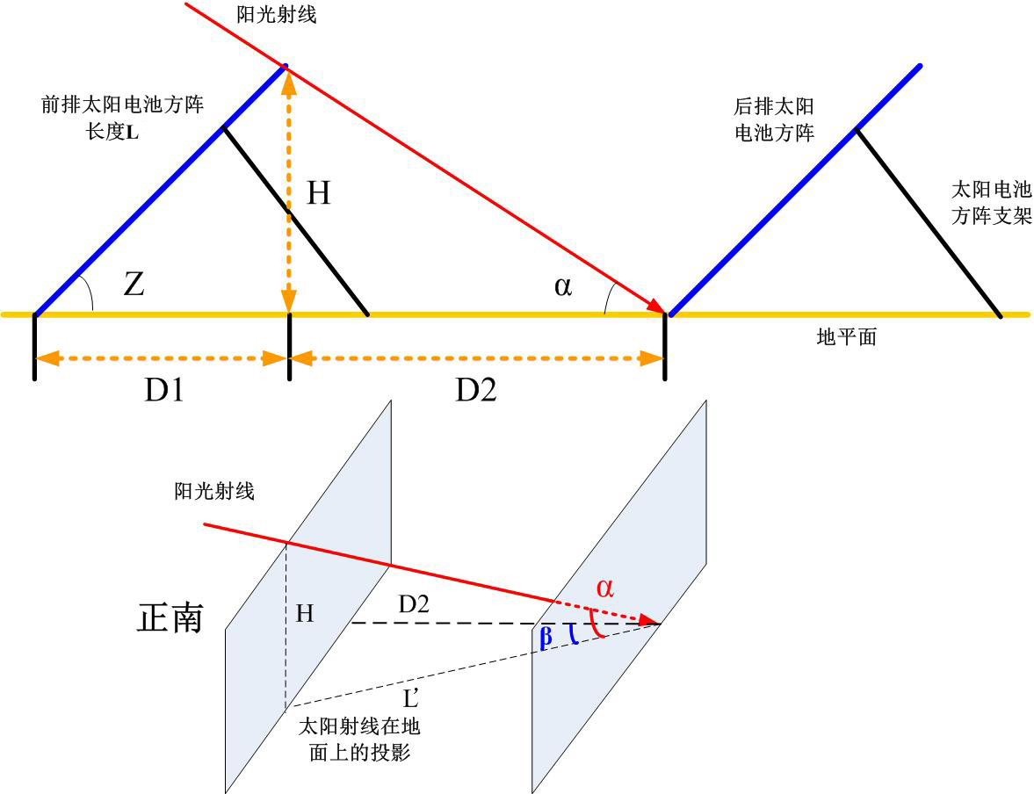

从上图可以看出：
D2 = cosβ×L′，L′ = H/tanα
D1 = L × cos Z H= L × sin Z
方阵间距 D = D1+D2 =（L × cos Z）+ （L×sin Z）×cosβ/ tanα

β：太阳方位角
α：太阳高度角
L′：太阳射线在地面上的投影
H：前后光伏方阵相对高度
L：光伏方阵纵向宽度
Z：光伏方阵倾角

太阳高度角计算公式：sinα = sinφ sinδ+cosφ cosδ cosω
太阳方位角计算公式：sinβ = cosδ sinω/cosα
cosβ= (sinφsinα- sinδ)/cosαcosφ
三角函数公式 tanα = sinα/ cosα
$s{\text{in}}^{2}α+{\text{cos}}^{2}α=1，\text{tan}α=\frac{\text{sin}α}{\text{cos}α}$
式中：
φ为当地纬度；
δ为太阳赤纬，
计算公式：δ=23.5sin[360(284+N)/365]
冬至日的太阳赤纬为-23.45度；
ω为时角，上午9:00的时角为45度。
cosβ/tanα = (sinφsinα- sinδ)/ cosαcosφtanα
= (sin²φ sinδ+sinφcosφ cosδ cosω-sinδ)/ cosφsinα
= (sin²φ sinδcosφ+ cos²φsinφcosδ cosω-cosφsinδ)/ cos²φsinα
= sinφcosδ cosω/sinα + cosφsinδ (sin²φ-1)/ cos²φsinα
= (sinφcosδ cosω - cosφsinδ)/ sinα
= (sinφcosδ cosω - cosφsinδ)/( sinφ sinδ+cosφ cosδ cosω)
分子和分母同时除以cosφsinδ，得到：
cosβ/tanα = (cosωtanφ – tanδ)/( cosω + tanφtanδ)
当赤纬角δ = -23.45度，时角ω = 45度时：
cosβ/tanα = （0.707 tanφ + 0.4338）/（0.707-0.4338 tanφ）
得到GB50797-2012中的固定方阵间距简单计算公式：
D = （L×cos Z）+（L×sin Z）×（0.707 tanφ + 0.4338）/（0.707-0.4338 tanφ）
说明：固定光伏方阵不一定朝向正南，也可能朝东、朝西或东南、西南等。通用的D2 公式为：D2 = cos（β-r）×L′，L′ = H/tanα，r为光伏方阵的方位角，而β-r则是阳光射线和方阵法线在地面上投影的夹角。通用公式适用于任意方位角，也适用于赤道坐标东西向间距的计算。是任意方向的通用公式，则间距不完全是南北向间距，而是前后排间距。
（二）计算实例
计算实例1：
地点：三亚 纬度：18.23度
不遮挡时段：冬至日上午9：00到下午3：00
冬至日实际日出日落时长：10小时54分，日出：6：33， 日落5：27
上午9：00太阳高度角=29.45度
天合255瓦组件：长1.685米，宽0.997米，组件效率：15.18%
组件安装：纵向4块组件排列
横向22块组件排列
方阵总功率：22.44kW
方阵倾角：等于纬度角18.23度
计算方法：
纵向4块组件排列，长度L=0.997×4=3.988米；
横向22块组件排列，宽度K=1.685×22=37.07米
光伏方阵间距为
D = D1+D2 =（L×cos Z）+（L×sin Z）×（0.707 tanφ + 0.4338）/（0.707-0.4338 tanφ）
D1 = L×cos Z= 3.988×cos（18.23）= 3.788米，
D2 =（L×sin Z）×（0.707 tanφ + 0.4338）/（0.707-0.4338 tanφ）=1.474米计算可得：方阵间距D = D1+D2=3.788+1.474=5.262米。
已知方阵宽度K = 37.07米，
得到方阵净占地S=D×K=5.262×37.07=195.062平方米。
方阵总功率22.44kW
计算出单位kW净占地：S₁=195.062/22.44=8.69平方米。
综合考虑到组件上下、左右间隔，方阵间距和方阵间道路，逆变器机房、升压变等占地，光伏方阵用地指标：
S₂₌8.69×（1+30%）=11.297平方米，
计算得到光伏方阵单位kW合理占地：11.297平方米。
即为11.297hm²/10MW。

计算实例2：
地点：三亚 纬度：18.23度
不遮挡时段：冬至日上午7：44到下午4：16
冬至日实际日出日落时长：10小时54分，日出：6：33， 日落5：27
上午7：44太阳高度角=15.00度
天合255瓦组件：长1.685米，宽0.997米，组件效率：15.18%
组件安装：纵向4块组件，长度L=3.988米；横向22块，宽度K：37.07米
方阵总功率：22.44kW
方阵倾角：等于纬度角18.23度
带入公式：D = （L×cos Z）+（L×sin Z）×（0.707 tanφ + 0.4338）/（0.707-0.4338 tanφ）
得到：D1 = 3.788米， D2 = 2.431米，方阵间距6.218米，已知方阵宽度K = 37.07米，得到方阵净占地230.515平方米。
方阵总功率22.44kW，单位kW净占地：10.27平方米，考虑到组件上下、左右间隔，方阵间距和方阵间道路，逆变器机房/升压变占地，区间内道路用地等，需要有大约30%的余量，得到光伏方阵单位kW合理占地：13.351平方米，高于上午9：00到下午3：00为不遮挡时段的占地。

二、固定式光伏方阵占地计算（Ⅱ类地形区）
（一）计算要点
- 固定式方阵坡地向南安装，不用考虑东西向遮挡，只需要考虑南北向间距；
- 以冬至日上午9：00到下午3：00不遮挡为准（不是北京时间，是当地太阳时，即正午12：00的太阳时角为零）；
- 方阵倾角等于当地纬度；
- 前排方阵高度H变为相对高度 h1，其它计算公式不变。
- 坡地方阵间距图示：
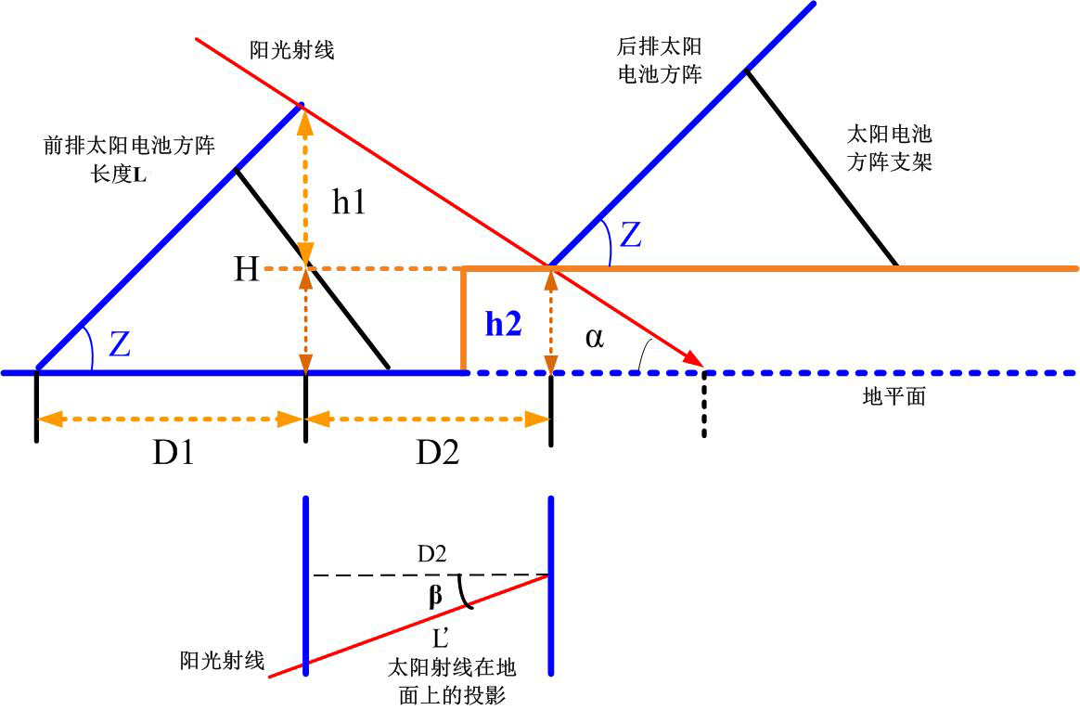
条件：已知前后排光伏方阵安装平面的高度差h2.
D1 = L × cos Z （与平地一致无变化）
D2 = cosβ×L′，L′ = h1/tanα
H= L × sin Z = h1+h2 h1=H-h2
方阵间距：D = D1+D2 =（L × cos Z）+ （L×sin Z-h2）×cosβ/ tanα

β：太阳方位角 α：太阳高度角 L′：太阳射线在地面上的投影
h1：前后光伏方阵相对高度 h2：前后排方阵高度差
H：前排方阵垂直高度
L：光伏方阵纵向宽度
Z：光伏方阵倾角
因计算方法相同，不再给出计算实例。

三、赤道坐标平单轴跟踪方阵占地计算
（一）计算要点
- 水平轴方阵东西向跟踪太阳时角，不用考虑南北向遮挡，只需要考虑东西向间距；
- 方阵运行方式：主轴东西向跟踪太阳时角，方阵最大向东倾角60度。当太阳时角大于方阵向东最大倾角时，方阵采用“反向跟踪”；当太阳时角达到最大倾角60度时，方阵开始随太阳时角旋转，有：A=ω，冬至日上午9：00时，所有纬度情况下均已经有A=ω，即A= 45度；
- 方阵东西向间距以冬至日上午9：00到下午3：00不遮挡为准（不是北京时间，是当地太阳时，即正午12：00的太阳时角为零）；
- 光伏组件水平安装在方阵主轴上，倾角等于零；
- 水平轴东西向跟踪仅适合于纬度在35度以下地区，纬度在35度以上地区由于冬季太阳过于斜射，余弦损失太大，不适用；
- 春分/秋分时节，日出时间为早上6：00，如果仍然定义为上午9：00不遮挡显然不合适，但如果定义为基本相同的太阳高度角不遮挡，则时间要提前到上午8：00不遮挡，方阵向东倾角也相应调整到60度，此时东西向间距要比冬至日上午9：00要大27%，占地面积也相应增大20%。因此，对于赤道坐标跟踪系统，由于东西向间距是占地的主要因素（固定方阵不必考虑东西向间距），而东西向间距不但受季节影响，还受所设定的不遮挡时间影响，不遮挡的时间越长，则占地越大，需要综合考虑占地和发电量的最优配比。
- 方阵间距图示：
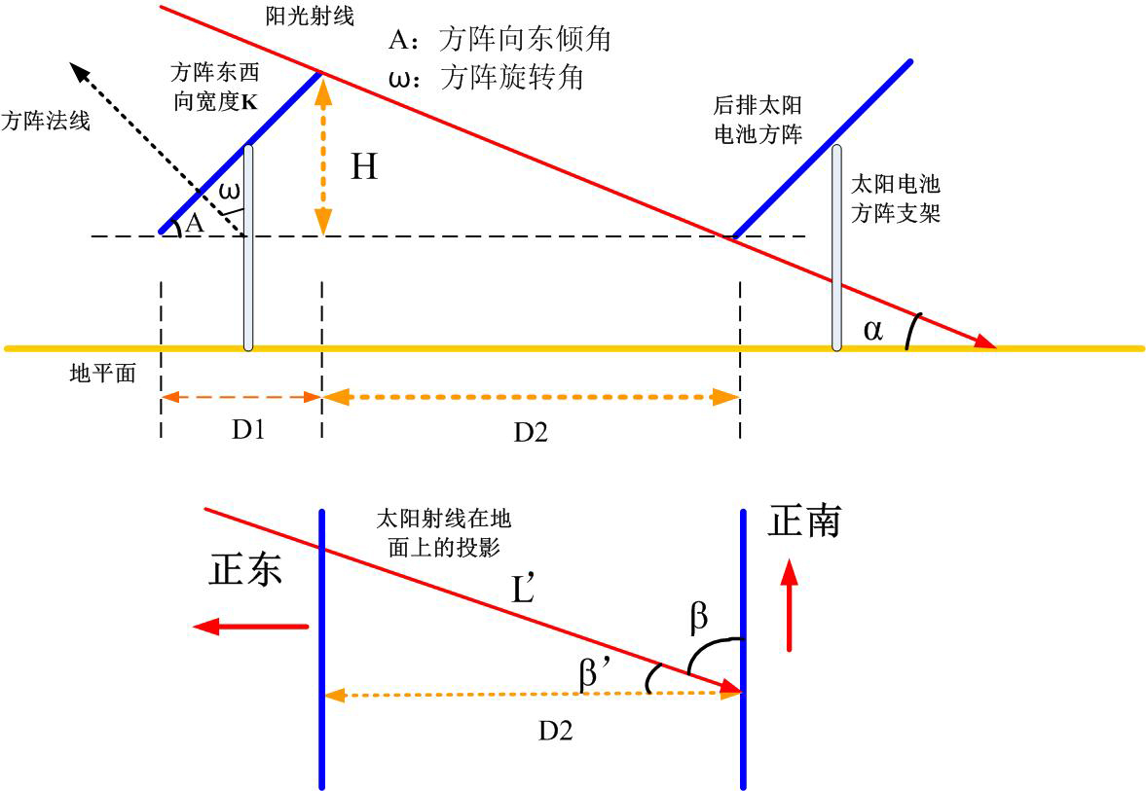
计算太阳电池方阵间距D，可以从下面4个公式求得：
D2 = L′×cosβ' β' =90-β
L′ = H/tanα H= K×sin A
α = arcsin(sinφsinδ+cosφcosδcosω)
β = arcsin(cosδ sinωcosα)
首先计算冬至上午9:00太阳高度角和太阳方位角，冬至时的赤纬角d是-23.45度，上午9:00的时角ω是45度，于是有：
α = arcsin (0.648 cos φ- 0.399sinφ)
β = arcsin（0.917× 0.707/cos α）
求出太阳高度角α后和太阳方位角后，即可求出太阳光在方阵后面的投影长度L′，再将L′折算到前后两排方阵之间的垂直距离D2：
D2 = L′ × cosβ' = H×cosβ' / tanα
D1 = K× cos A

（二）计算实例3：
青海格尔木纬度φ = 36.25度，求太阳电池方阵东西向间距：
不遮挡时段：冬至日上午9：00到下午3：00
冬至日实际日出日落时长：9小时31.6分，日出：7：14， 日落4：46
上午9：00太阳高度角=16.728度
取δ = -23.45, ω = 45, 有：
天合255瓦组件：长1.685米，宽0.997米，组件效率：15.18%
组件安装：东西向并排安装2块组件，东西向宽度K=1.994米，南北向主轴上水平安装2排各20块组件，方阵总长度33.70米；
方阵总功率：10.20kW
方阵倾角：水平安装在主轴上，倾角等于零；
方阵向东倾角等于时角45度。
得到：D1 = 1.410米， D2 = 3.178米，方阵间距4.588米，已知方阵长度33.7米，得到方阵净占地154.605平方米。
方阵总功率10.20kW，单位kW净占地：15.157平方米，考虑到组件上下、左右间隔，方阵间道路（已经有了方阵东西向间距，不必另外增加），逆变器机房/升压变占地等，需要有大约30%的余量，得到光伏方阵单位kW合理占地：19.70平方米。

计算实例4：
青海格尔木纬度φ = 36.25度，求太阳电池方阵春分时东西向间距：
春分日实际日出日落时长：12小时，日出：6：00， 日落6：00
太阳高度角=20.0度时的时间是上午7：40（时角为64.906度，大于60度）
天合255瓦组件：长1.685米，宽0.997米，组件效率：15.18%
组件安装：东西向并排安装2块组件，东西向宽度K=1.994米，南北向主轴上水平安装2排各20块组件，方阵总长度33.70米；
方阵总功率：10.20kW
方阵倾角：水平安装在主轴上，倾角等于零；
方阵7：40时向东倾角等于机械最大倾角60度。
得到：D1 = 0.997米， D2 = 4.572米，方阵间距5.569米，已知方阵长度33.7米，得到方阵净占地187.691平方米。
方阵总功率10.20kW，单位kW净占地：18.401平方米，考虑到组件上下、左右间隔，方阵间道路（已经有了方阵东西向间距，不必另外增加），逆变器机房/升压变占地等，需要有大约30%的余量，得到光伏方阵单位kW合理占地：23.921平方米，比冬至日占地还要大。

四、赤道坐标斜单轴跟踪方阵占地计算
（一）计算要点
- 斜单轴太阳跟踪器的光伏方阵在主轴上向南倾斜纬度角，方阵东西向跟踪太阳时角，不但需要考虑东西向方阵间距，还要考虑光伏方阵之间在主轴上的间距；
- 方阵运行方式：主轴东西向跟踪太阳时角，方阵最大向东倾角60度。当太阳时角大于方阵向东最大倾角时，方阵采用“反向跟踪”；当太阳时角达到最大倾角60度时，方阵开始随太阳时角旋转，有：A=ω，冬至日上午9：00时，所有纬度情况下均已经有A=ω，即A= 45度；
- 方阵东西向间距以冬至日上午9：00到下午3：00不遮挡为准（不是北京时间，是当地太阳时，既正午12：00的太阳时角为零）；
- 光伏组件倾斜纬度角安装在方阵主轴上，需要计算合理间距；
- 斜单轴太阳跟踪器适合于任何纬度地区，不存在冬季余弦损失太大的问题；
- 春分/秋分时节，日出时间为早上6：00，如果提前到上午8：00以后不遮挡，方阵向东倾角也相应调整到60度，则占地面积要比冬至日上午9：00要大27%。因此，对于赤道坐标跟踪系统，由于东西向间距是占地的主要因素（固定方阵不必考虑东西向间距），而东西向间距不但受季节影响，还受所设定的不遮挡时间影响，不遮挡的时间越长，则占地越大，需要综合考虑占地和发电量的最优配比。
（二）东西向间距计算：
尽管光伏方阵在主轴上有倾角，但东西向间距计算方法仍然与水平轴跟踪一致。
方阵间距图示如下：
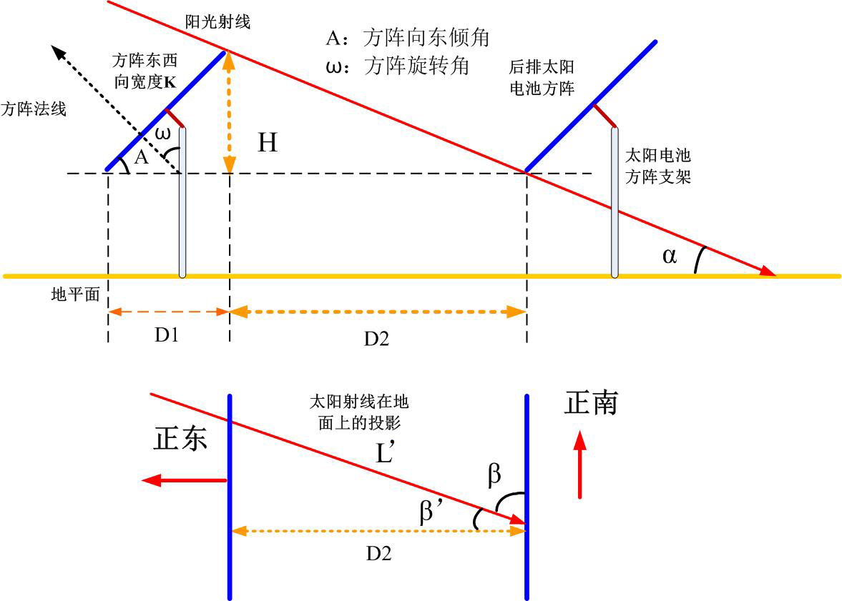

计算实例5：
计算太阳电池方阵东西向间距D，可以从下面几个公式求得：
D2 = L′×cosβ' β' =90-β
L′ = H/tanα H= K×sin A
D2 = L′ × cosβ' = H×cosβ' / tanα
D1 = K× cos A
D = D1+D2 = K× cos A+ K×sin A ×cosβ' / tanα

青海格尔木纬度φ = 36.25度，求太阳电池方阵东西向间距：
天合255瓦组件：长1.685米，宽0.997米，组件效率：15.18%
组件安装：东西向并排安装2块组件，东西向宽度K=1.994米，向东倾角45度；
得到：D1 = 1.410米， D2 = 3.176米，方阵东西向间距4.586米。

（三）南北向间距计算：
方阵南北向间距图示如下：
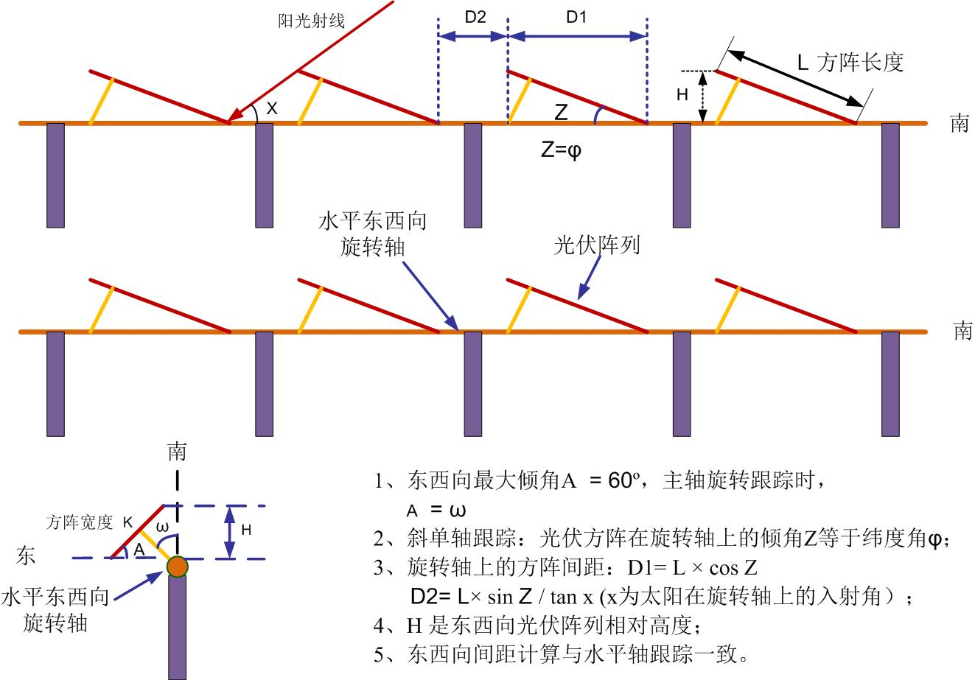
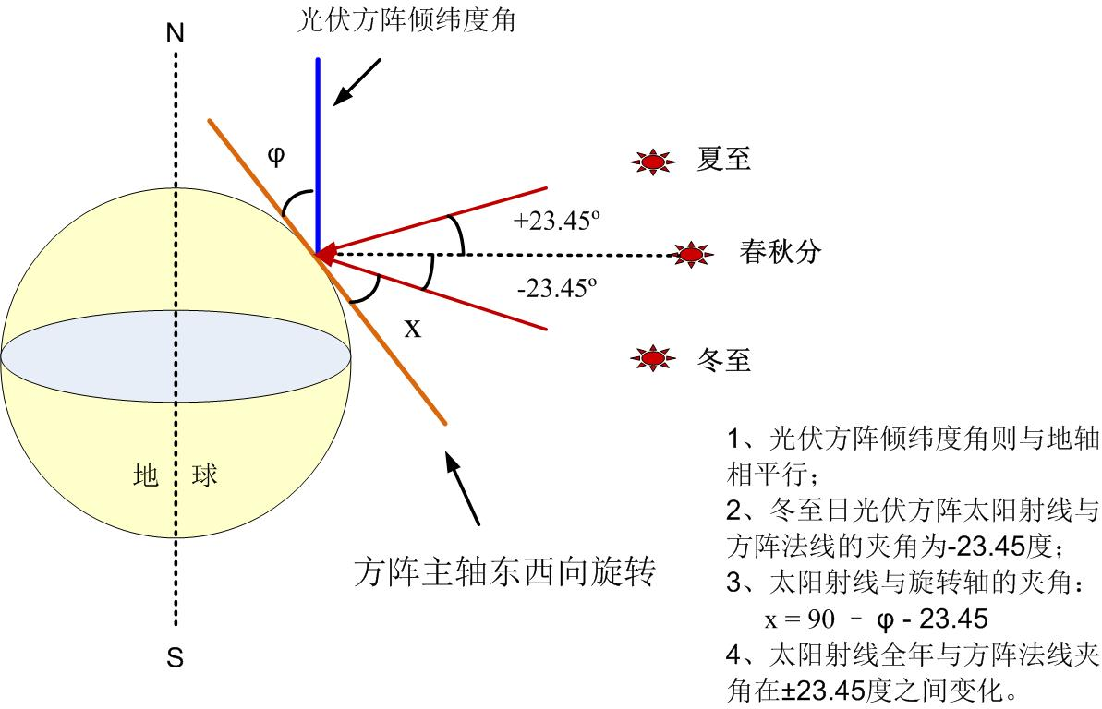

计算太阳电池方阵主轴上间距D，可以从下面几个公式求得：
D = D1+D2
D1 = L× cos Z
D2 = H/tanx H= L×sin Z
X = 90-φ-23.45
D = D1+D2 = L× cos Z+ L×sin Z / tan(90-φ-23.45)
计算实例6：
青海格尔木纬度φ = 36.25度，求太阳电池方阵在主轴上的间距：
天合255瓦组件：长1.685米，宽0.997米，组件效率：15.18%
组件安装：东西向并排2块组件，倾纬度角（Z=φ=36.25度）安装在主轴上L′=1.685米； X = 30.3度
得到：D1 = 1.359米， D2 = 1.705米，方阵南北向间距3.064米。
计算实例7：
斜单轴跟踪单位kW占地计算：
东西向方阵间距4.586米，主轴上方阵间距（即南北向间距）3.064米，得到方阵净占地14.05平方米。
方阵一共2块组件，总功率510W（0.51kW），单位kW净占地：27.55平方米，考虑到组件间隔、方阵间道路、逆变器机房占地等，需要有大约30%的余量，得到光伏方阵单位kW合理占地：35.815平方米。

五、赤道坐标双轴跟踪方阵占地计算
（一）计算要点
- 双轴太阳跟踪器的光伏方阵在主轴上始终跟踪太阳赤纬角，方阵东西向跟踪太阳时角，不但需要考虑东西向方阵间距，还要考虑光伏方阵之间在主轴上的间距。计算占地时，则仅仅考虑方阵冬至日倾斜最大倾角（即阴影最长）时的情况；
- 方阵运行方式：聚光光伏方阵一般采用双轴跟踪器，聚光光伏需要随时准确跟踪太阳，为了最大限度提高发电量，要求提前1小时（冬至日上午8：00，而不是9：00）对准太阳，且东西向互相不遮挡。方阵主轴东西向跟踪太阳时角，方阵最大向东倾角60度。当太阳时角大于方阵向东最大倾角时，方阵采用“反向跟踪”；当太阳时角达到最大倾角60度时，方阵开始随太阳时角旋转，有：A=ω，冬至日上午8：00时，所有纬度（北纬18-50度）情况下均已经有A=ω，即A= 60度；
- 方阵东西向间距以冬至日上午8：00到下午4：00不遮挡为准（不是北京时间，是当地太阳时，即正午12：00的太阳时角为零）；
- 当然，太阳高度角和太阳方位角也相应采用冬至日8:00太阳时；
- 光伏组件冬至日在主轴上的倾角为当地纬度+23.45度，此时方阵在主轴上的间距最大。
- 赤道座标双轴太阳跟踪器适合于任何纬度地区，不存在冬季余弦损失太大的问题；
- 对于赤道坐标跟踪系统，由于东西向间距是占地的主要因素（固定方阵不必考虑东西向间距），而东西向间距不但受季节影响，还受所设定的不遮挡时间影响，不遮挡的时间越长，则占地越大，需要综合考虑占地和发电量的最优配比。
（二）东西向间距计算
尽管光伏方阵在主轴上有倾角，但东西向间距计算方法仍然与水平轴跟踪一致。
方阵间距图示如下：

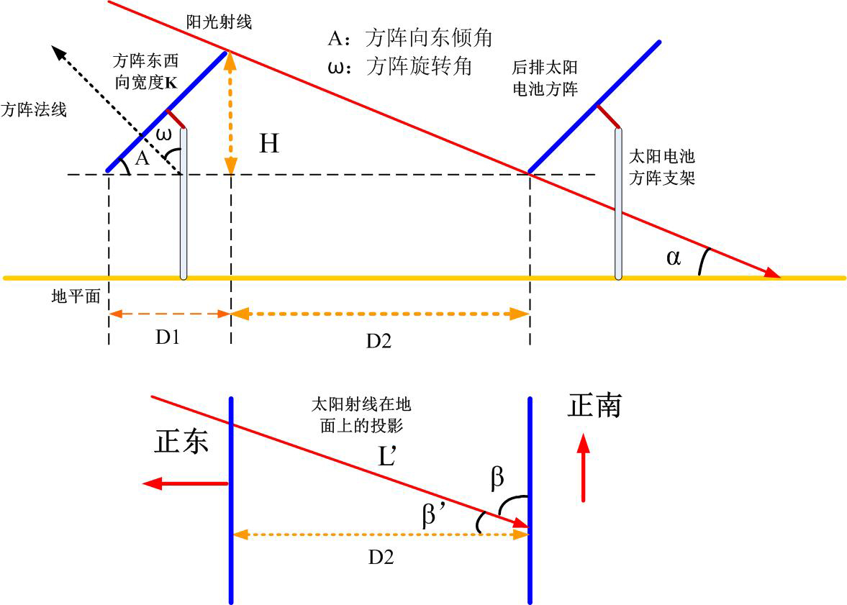
计算实例7：
计算太阳电池方阵东西向间距D，可以从下面几个公式求得：
D2 = L′×cosβ' β' =90-β
L′ = H/tanα H= K×sin A
D2 = L′ × cosβ' = H×cosβ' / tanα
D1 = K× cos A
D = D1+D2 = K× cos A+ K×sin A ×cosβ' / tanα

青海格尔木纬度φ = 36.25度，求太阳电池方阵东西向间距：
天合255瓦组件：长1.685米，宽0.997米，组件效率：15.18%
组件安装：东西向并排安装2块组件，东西向宽度K=1.994米；
向东倾角A=60度，上午8：00太阳高度角仅7.736度。
得到：D1 = 0.997米， D2 = 8.317米，方阵东西向间距9.314米。
（三）南北向间距计算
方阵南北向间距图示如下：

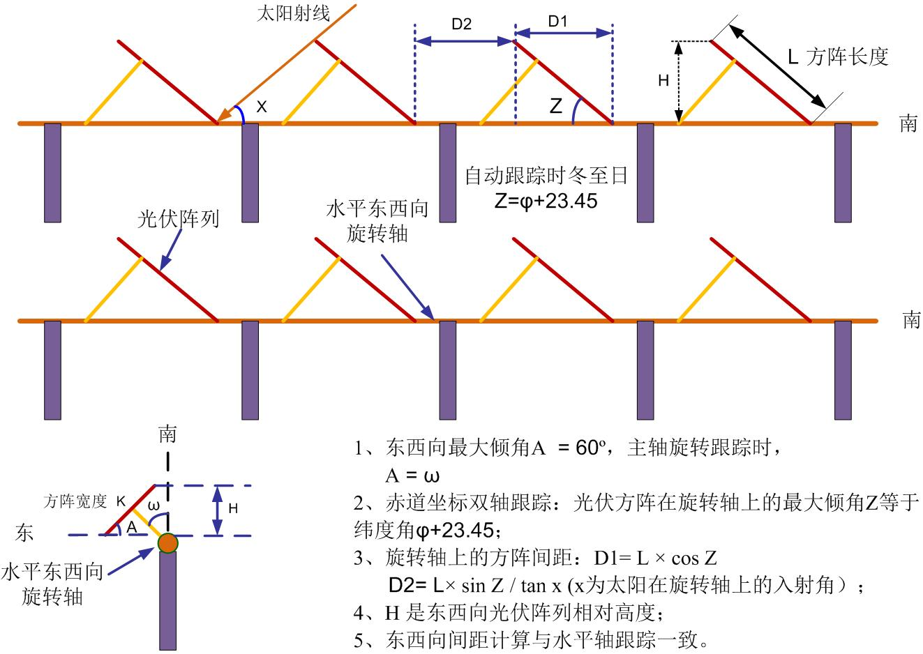

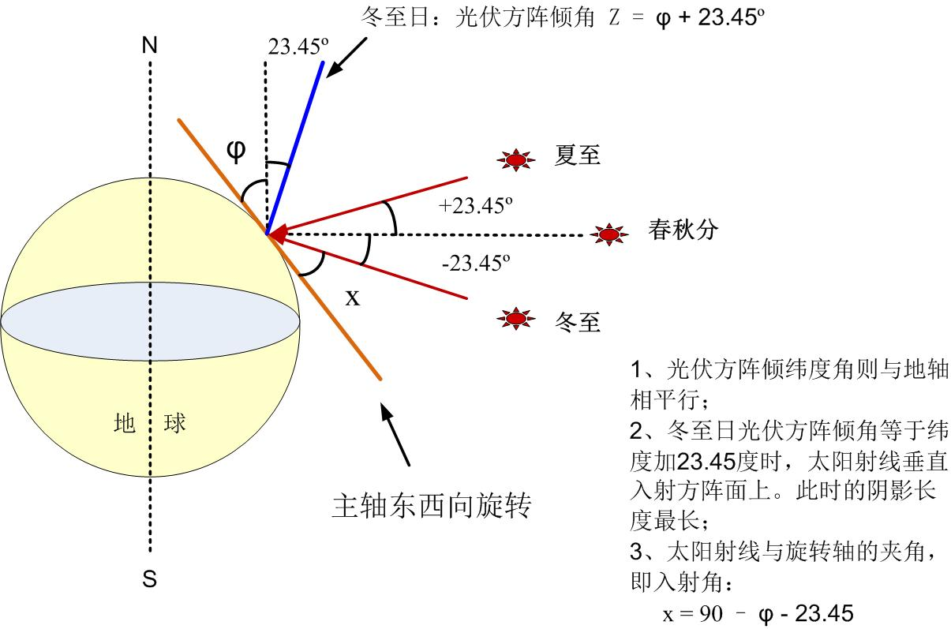

计算太阳电池方阵主轴上间距D，可以从下面几个公式求得：
D = D1+D2
D1 = L× cos Z
D2 = H/tanx H= L×sin Z
X = 90-φ-23.45
D = D1+D2 = L× cos Z+ L×sin Z / tan(90-φ-23.45)
计算实例8：
青海格尔木纬度φ = 36.25度，求太阳电池方阵在主轴上的间距：
天合255瓦组件：长1.685米，宽0.997米，组件效率：15.18%
组件安装：东西向并排2块组件，倾纬度角+23.45（Z=φ+23.45=59.70度）安装在主轴上L=1.685米； 太阳在主轴上的入射角X = 30.3度
得到：D1 = 0.85米， D2 = 2.49米，方阵南北向间距D1+D2=3.34米。
斜单轴跟踪单位kW占地计算
东西向方阵间距9.314米，主轴上方阵间距（即南北向间距）3.34米，得到方阵净占地31.109平方米。
方阵一共2块组件，总功率510W（0.51kW），单位kW净占地：60.998平方米，考虑到组件间隔、方阵间道路、逆变器机房占地等，需要有大约30%的余量，得到光伏方阵单位kW合理占地：79.297平方米。

六、地平坐标双轴跟踪系统占地计算
（一）计算要点
- 地平坐标双轴跟踪系统是跟踪太阳高度角和太阳方位角；
- 光伏方阵的方位角可以360度旋转，因此可以从日出就开始跟踪，始终有方阵方位角=太阳方位角β；为了使阳光射线垂直于方阵平面，要求方阵倾角等于太阳高度角的余角，即：Z=90-α，但是方阵倾角受机械加工限制，不可能倾70度以上，一般设计最大倾角为60度；
- 冬至日上午9：00时，在18-50度纬度范围内，太阳高度角均小于30度，即光伏方阵即使倾斜到最大倾角60度，太阳射线仍无法达到垂直入射。因此，即使对于聚光光伏，也仍以冬至日上午9：00到下午3：00不遮挡为准（不是北京时间，是当地太阳时，既正午12：00的太阳时角为零）；
- 日出到太阳高度角达到30度之前，方阵采用“反向跟踪”，一旦太阳高度角达到30度，光伏方阵开始跟踪太阳高度角，此时开始有Z=90-α；鉴于高纬度地区占地过大，建议纬度40度以上地区，方阵最大倾角调整为45度。
- 方阵间距图示：
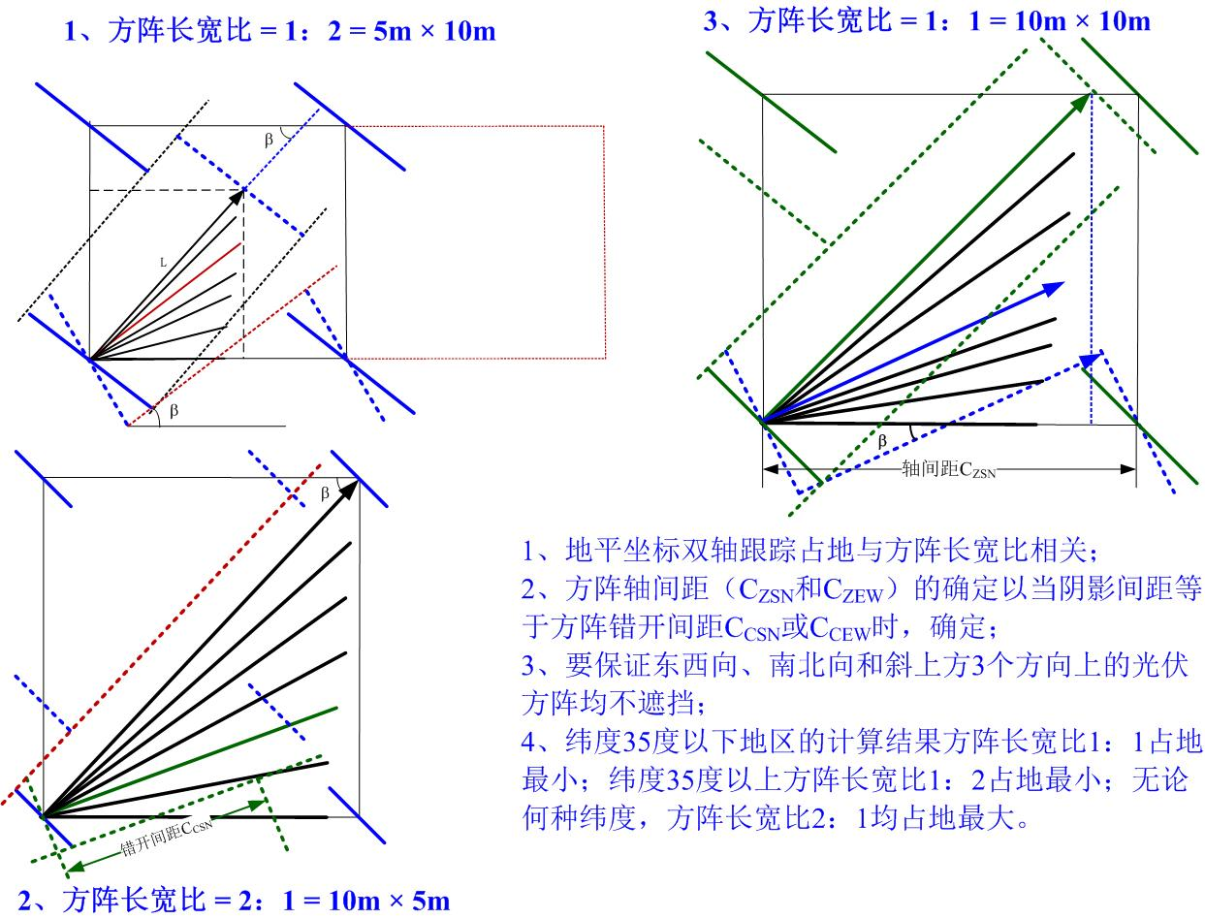

从上图可以看出：
- 地平坐标双轴跟踪占地与方阵长宽比相关；
- 方阵最大轴间距（C_{ZSN}和C_{ZEW}）的确定以当阴影间距等于方阵错开间距C_{CSN}或C_{CEW}时确定。南北向错开轴间距随时角向正午移动从初始错开轴间距逐渐趋向无穷大；东西向错开轴间距随时角向正午移动从初始错开轴间距逐渐趋向于零；
- 要保证东西向、南北向和斜上方3个方向上的光伏方阵均不遮挡；
- 纬度35度以下地区的计算结果方阵长宽比1：1占地最小；纬度35度以上方阵长宽比1：2占地最小；无论何种纬度，方阵长宽比2：1均占地最大。

表1、不同长宽比方阵在不同纬度地区占地计算（m²）
方阵长（m） | 方阵宽（m） | 纬度
方阵长（m） | 方阵宽（m） | 20 | 30 | 40
5 | 10 | 31.694 | 34.190 | 36.969
10 | 5 | 36.210 | 58.286 | 98.619
10 | 10 | 22.669 | 32.374 | 49.310

上表条件：1）光伏组件效率14%；2）地平坐标双轴跟踪系统；
3）冬至日上午9点不遮挡。

前后排阴影长度 D = D1+D2 =（H × cos Z）+ （H ×sin Z）/ tanα
最长阴影长度时的南北间距D_{YSN} = D× cosα
最长阴影长度时的东西和南北间距D_{YEW} = D× sinα
最长阴影平移南北间距 D_{PSN} = D/ cosβ
最长阴影平移东西间距 D_{PEW} = D/ sinβ
H为前排方阵高度。

方阵南北向错开间距 C_{CSN} = K/tanβ
方阵东西向错开间距 C_{CEW} = K×tanβ
方阵南北向轴间距 C_{ZSN} = C_{CSN} /cosβ
方阵东西向轴间距 C_{ZEW} = C_{CEW} /sinβ
K为方阵宽度。
β为太阳方位角
δ为太阳赤纬，冬至日的太阳赤纬为-23.45度；
ω为时角，上午9:00的时角为45度。
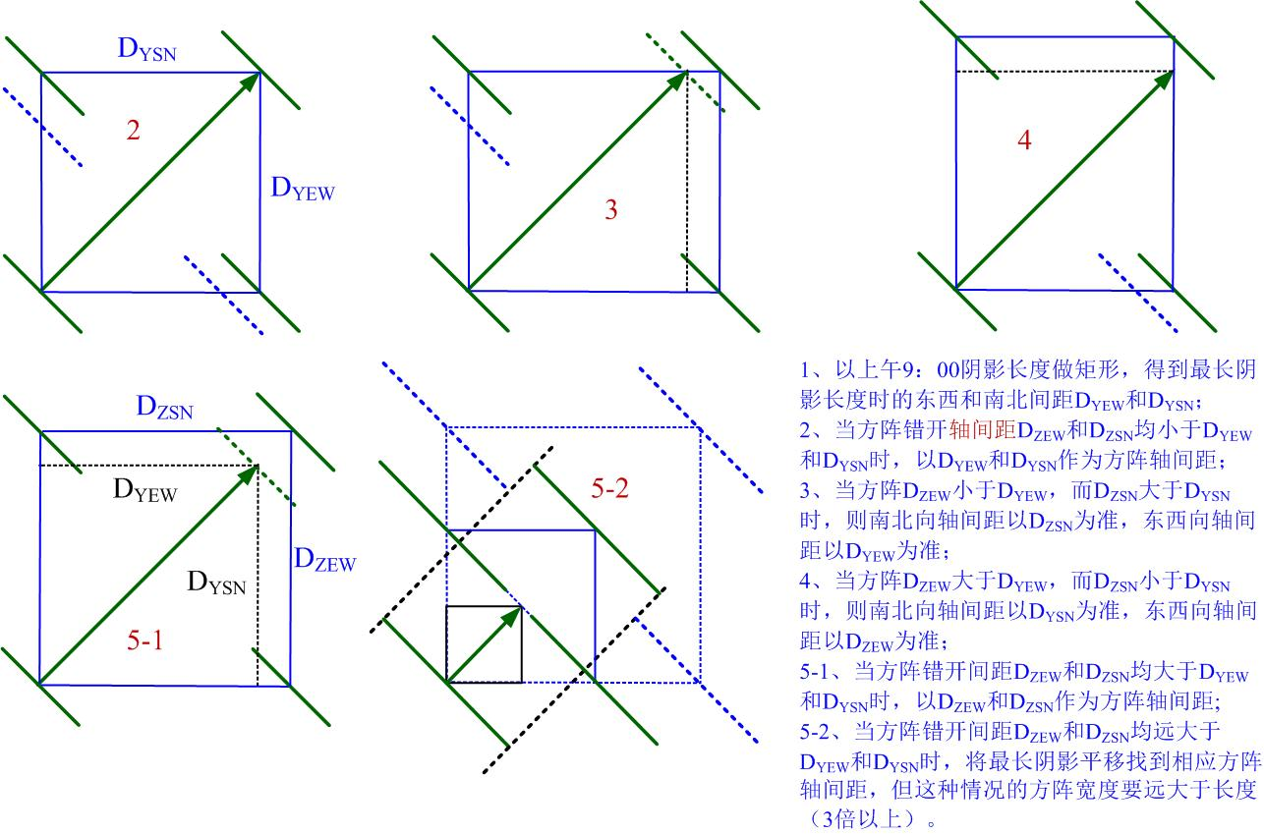

从上图可以看出：
- 以上午9：00阴影长度做矩形，得到最长阴影长度时的东西和南北间距D_{YEW}和D_{YSN}；
- 图2：当方阵最大错开轴间距D_{ZEW}和D_{ZSN}均小于D_{YEW}和D_{YSN}时，以D_{YEW}和D_{YSN}作为方阵轴间距；
- 图3：当方阵D_{ZEW}小于D_{YEW}，而D_{ZSN}大于D_{YSN}时，则南北向轴间距以D_{ZSN}为准，东西向轴间距以D_{YEW}为准；
- 图4：当方阵D_{ZEW}大于D_{YEW}，而D_{ZSN}小于D_{YSN}时，则南北向轴间距以D_{YSN}为准，东西向轴间距以D_{ZEW}为准；
- 图5-1：当方阵错开间距D_{ZEW}和D_{ZSN}均大于D_{YEW}和D_{YSN}时，以D_{ZEW}和D_{ZSN}作为方阵轴间距;
- 图5-2：当方阵错开间距D_{ZEW}和D_{ZSN}均远大于D_{YEW}和D_{YSN}时，将最长阴影平移找到相应方阵轴间距，这种情况的方阵宽度要远大于长度，因此最小东西间距和最小南北间距均不得小于方阵宽度，否则左右方阵平行时会相互碰撞。

（二）计算实例9：
地点：北京 纬度：39.8度
天合255瓦组件：长1.685米，宽0.997米，组件效率：15.18%
组件安装：纵向5块组件横排，长度L=4.985米；横向4块，宽度K=6.74米
方阵总功率：5.1kW
方阵倾角：早9：00时倾角45度
得到：D1 = 3.525米， D2 = 14.031米，方阵上午9：00阴影长度17.556米；
方阵宽度最长阴影长度时的南北间距D_{YSN} = 13.051米
方阵宽度最长阴影长度时的东西间距D_{YEW} = 11.742米
南北向最大错开轴间距（时角-28.7度） D_{ZSN} = 14.252米 （大于D_{YSN}）
东西向最大错开轴间距（初始错开轴间距） D_{YEW} = 9.067米 （小于D_{YEW}）
方阵占地 = D_{ZSN} × D_{YEW}= 14.252米×11.742米 = 167.353平方米
得到方阵净占地167.353平方米。
方阵总功率5.1kW，单位kW净占地：32.814平方米，考虑到组件间隔、方阵间道路、逆变器机房占地等，需要有大约30%的余量，得到光伏方阵单位kW合理占地：42.6582平方米。
另：变电站及运行管理中心用地、集电线路用地、交通工程用地规模（计算略）

北京实例间距计算结果图示：
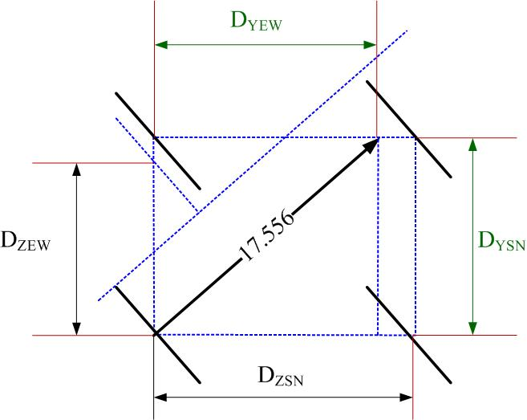

计算实例10：
地点：格尔木 纬度：36.25度
天合255瓦组件：长1.685米，宽0.997米，组件效率：15.18%
组件安装：纵向5块组件横排，长度L′=4.985米；横向4块，宽度K=6.74米
方阵总功率：5.1kW
方阵倾角：早9：00时倾角60度
得到：D1 = 2.493米， D2 = 14.363米，方阵上午9：00阴影长度16.856米；
方阵宽度最长阴影长度时的南北间距D_{YSN} = 12.40米
方阵宽度最长阴影长度时的东西间距D_{YEW} = 11.418米
南北向最大错开轴间距（时角29.01度） D_{ZSN} = 13.806米 （大于D_{YSN}）
东西向最大错开轴间距（初始错开轴间距） D_{YEW} = 9.162米 （小于D_{YEW}）
方阵占地 = D_{ZSN} × D_{YEW}= 13.806米×11.418米 = 157.635平方米
得到方阵净占地157.635平方米。
方阵总功率5.1kW，单位kW净占地：30.909平方米，考虑到组件间隔、方阵间道路、逆变器机房占地等，需要有大约30%的余量，得到光伏方阵单位kW合理占地：40.182平方米。

格尔木实例间距计算结果图示：
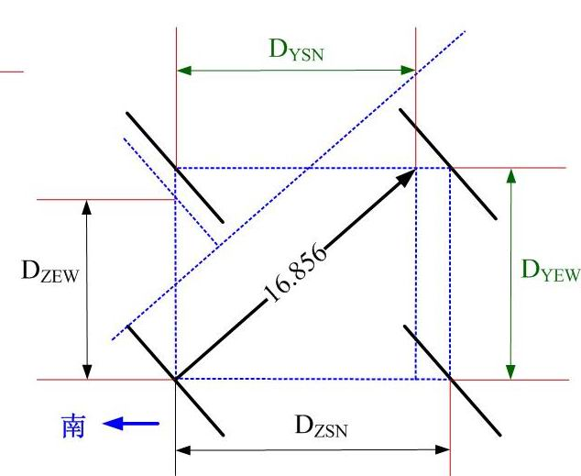
七、地平坐标方位角跟踪系统占地计算
（一）计算要点
- 地平坐标方位角跟踪系统只跟踪太阳方位角，方阵倾角固定，一般倾纬度角，即Z=φ；
- 此种跟踪方式只适用于平板组件，不适用于聚光光伏。光伏方阵的方位角可以360度旋转，始终有方阵方位角=太阳方位角β；
- 以冬至日上午9：00到下午3：00不遮挡为准（不是北京时间，是当地太阳时，既正午12：00的太阳时角为零）；
- 除了方阵的倾角固定外，计算方法与地平坐标双轴跟踪一致。
- 方阵间距图示：
从上图可以看出：
- 以上午9：00阴影长度做矩形，得到最长阴影长度时的东西和南北间距D_{YEW}和D_{YSN}；
- 图2：当方阵最大错开轴间距D_{ZEW}和D_{ZSN}均小于D_{YEW}和D_{YSN}时，以D_{YEW}和D_{YSN}作为方阵轴间距；
- 图3：当方阵D_{ZEW}小于D_{YEW}，而D_{ZSN}大于D_{YSN}时，则南北向轴间距以D_{ZSN}为准，东西向轴间距以D_{YEW}为准；
- 图4：当方阵D_{ZEW}大于D_{YEW}，而D_{ZSN}小于D_{YSN}时，则南北向轴间距以D_{YSN}为准，东西向轴间距以D_{ZEW}为准；
- 图5-1：当方阵错开间距D_{ZEW}和D_{ZSN}均大于D_{YEW}和D_{YSN}时，以D_{ZEW}和D_{ZSN}作为方阵轴间距;
- 图5-2：当方阵错开间距D_{ZEW}和D_{ZSN}均远大于D_{YEW}和D_{YSN}时，将最长阴影平移找到相应方阵轴间距，这种情况的方阵宽度要远大于长度，因此最小东西间距和最小南北间距均不得小于方阵宽度，否则左右方阵平行时会相互碰撞。

（二）计算实例11：
地点：北京 纬度：39.8度
天合255瓦组件：长1.685米，宽0.997米，组件效率：15.18%
组件安装：纵向5块组件横排，长度L=4.985米；横向4块，宽度K=6.74米
方阵总功率：5.1kW
方阵倾角：固定等于纬度39.8度
得到：D1 = 3.83米， D2 = 12.701米，方阵上午9：00阴影长度16.531米；
方阵宽度最长阴影长度时的南北间距D_{YSN} = 12.289米
方阵宽度最长阴影长度时的东西间距D_{YEW} = 11.057米
南北向最大错开轴间距（时角29.59度） D_{ZSN} = 13.891米 （大于D_{YSN}）
东西向最大错开轴间距（初始错开轴间距） D_{YEW} = 9.067米 （小于D_{YEW}）
方阵占地 = D_{ZSN} × D_{YEW}= 12.289米×11.057米 = 153.597平方米
得到方阵净占地153.597平方米。
方阵总功率5.1kW，单位kW净占地：30.117平方米，考虑到组件间隔、方阵间道路、逆变器机房占地等，需要有大约30%的余量，得到光伏方阵单位kW合理占地：39.152平方米。

计算实例12：
地点：格尔木 纬度：36.25度
天合255瓦组件：长1.685米，宽0.997米，组件效率：15.18%
组件安装：纵向5块组件横排，长度L=4.985米；横向4块，宽度K=6.74米
方阵总功率：5.1kW
方阵倾角：固定等于纬度36.25度
得到：D1 = 4.020米， D2 = 9.808米，方阵上午9：00阴影长度13.828米；
方阵宽度最长阴影长度时的南北间距D_{YSN} = 10.172米
方阵宽度最长阴影长度时的东西间距D_{YEW} = 9.366米
南北向最大错开轴间距（时角31.79度） D_{ZSN} = 12.821米 （大于D_{YSN}）
东西向最大错开轴间距（初始错开轴间距） D_{YEW} = 9.162米 （小于D_{YEW}）
方阵占地 = D_{ZSN} × D_{YEW}= 12.821米×9.366米 = 120.083平方米
得到方阵净占地120.083平方米。
方阵总功率5.1kW，单位kW净占地：23.546平方米，考虑到组件间隔、方阵间道路、逆变器机房占地等，需要有大约30%的余量，得到光伏方阵单位kW合理占地：30.610平方米。

八、地平坐标高度角跟踪系统占地计算
（一）计算要点
- 地平坐标高度角跟踪系统只跟踪太阳高度角，方阵方位角可以朝南、朝东、朝西、朝东南、朝西南等任意；
- 此种跟踪方式一般用于光伏遮阳板，很少用于大型地面电站，也有一年调整倾角数次的安装运行方式；
- 如果此种运行方式用于地面电站，则占地计算方法与固定安装相同，无论光伏方阵每天的倾角如何变化，也无论光伏方阵一年当中的倾角如何变化，只需要计算冬至日上午9：00时光伏方阵的占地即可。可以采用固定方阵占地的通用公式： D=D1+D2， D1 = L × cos Z
D2 = cos（β-r）×L′
L′ = H/tanα，H= L × sin Z

附加说明

编制单位和主要起草人员名单

主编部门：国土资源部
主要编制单位：国土资源部土地整治中心
河北省土地整理服务中心
上海电力设计院有限公司
北方设计研究院电力设计研究所
主要起草人： 郑凌志 何凤山 张 辉 范树印 罗 明 雷爱先
王斯成 周 霆 黄 清 纪成旺 陶晓龙 杨 红
雷逢春 陈洁丽 赵维全 赵利华 张 莹 邹 辉
王彦茹 周 治 王春宇

附件

《光伏发电站工程项目用地控制指标》

条文说明

1 基本规定

1.1 本条说明了本用地指标的适用范围。主要适用于新建、改建和扩建的地面光伏发电站工程项目。
改建、扩建项目应充分利用既有场地和设施，当需新增用地时，其用地指标应控制在本指标中相同建设规模工程用地指标范围内。技术改造升级工程应在满足生产要求和安全环保的前提下，宜在原有场地内进行，尽量不新增用地。
1.2 本条说明了光伏发电站工程建设应遵循的原则。土地是有限的自然资源，是各类建设项目进行建设的重要物质基础和人类赖以生存的基本条件。节约集约用地是我国的基本国策。光伏发电站工程项目建设在综合考虑光能资源、场址、环境等建设条件的同时，应尽量利用未利用地，不占或少占农用地，使土地资源科学利用和有效优化配置。
1.3 本条说明了光伏发电站的建设应具有符合光伏发展的需要。光伏产业全球能源科技和产业的重要发展方向，是具有巨大发展潜力的朝阳产业，也是我国具有国际竞争优势的战略性新兴产业。在建设过程中应符合市场的发展规律，体现科学、合理和节约集约用地的原则。
1.4 本条说明了本用地指标的作用。在可行性研究(初步设计)阶段，本用地指标可作为确定建设项目用地初步规模和申请项目用地预审的依据,作为核定和审批建设项目的尺度。
本用地指标既是建设单位可行性研究报告、规划设计以及初步设计文件过程中确定项目用地规模的重要标准，又是国土资源主管部门用地审批、土地供应、供后监管的依据。是核定和审批光伏发电工程项目用地规模的尺度。
本用地指标不能作为确认土地使用权的依据。
1.5 本条说明了本指标在可行性研究(初步设计)阶段的运用。可行性研究报告(初步设计)阶段是落实建设项目的外部条件，并根据其相关条件提出项目建设的总平面布置的设想。在可行性研究(初步设计)阶段要参照本指标所确定的总体规模和各功能分区规模范围内进行核定布局。可行性研究报告中对于建设项目总规模和功能分区规模的确定与本指标的对应情况，应在可行性研究报告中单独成章，进行详细说明。
1.6 本条说明了本指标在用地审核阶段的作用。用地指标作为建设项目土地供应规模确定的依据，在项目用地审核阶段应严格按照本指标的内容核定光伏发电站的用地规模。
1.7 本条说明了本用地指标在土地供应阶段的作用。国土资源主管部门在国有用地划拨决定书和出让合同中，要明确土地使用标准的相关内容。在核发划拨决定书、签订出让合同时，要明确规定或约定建设项目用地总面积、各功能分区面积及土地用途、容积率控制要求、违规违约责任等。
国土资源主管部门要重点加强对土地使用标准适用情况的审核，并对适用标准的真实性负责。
1.8 本条说明本用地指标中总体指标和分项指标的适用条件以及光伏发电站工程项目总用地指标面积的计算方法。
1.9 本条说明了本用地指标土地使用范围。用地指标所指的土地既包括农用地，也包括建设用地和未利用地，项目用地无论占用的是农用地还是建设用地，或是未利用地，均应该遵循本指标的要求，进行项目用地规模核定。
1.10 本条对超标准建设项目用地提出要求。《国土资源部关于严格执行土地使用标准大力促进节约集约用地的通知》(国土资发〔2012〕132号)文件要求：对因安全生产、地形地貌、工艺技术等有特殊要求的建设项目确需突破土地使用标准的，用地单位应报请当地国土资源主管部门同意。国土资源主管部门应组织有关专家论证评估，集体决策，合理确定项目用地规模，出具审查意见，报同级人民政府批准后，方可办理相关用地审批、供应手续。
对于光伏发电站建设项目来说，因安全生产、地形地貌、工艺技术等有特殊要求，确需突破本指标确定的用地规模和功能分区的建设项目，需要开展节地评价，评审论证。
1.11 本条明确光伏组件发电效率的要求。光伏发电站的用地规模与光伏组件的发电效率有直接的关系，一般同等条件下，发电效率越高，项目占地越少，光伏发电站工程项目建设在经济技术合理的条件下，应优先采用技术先进、发电效率高的光伏组件。此外，光伏发电站工程的选址、光伏方阵的排列及布置、施工方案、运行管理模式等都决定着用地面积的大小。因此，光伏发电站工程建设应从光伏组件选择、规划设计、建设施工、工程管理等方面，采取综合措施，尽可能地减少占地面积，提高节约集约用地水平。
1.12 本用地指标的确定是在遵循国家有关法律、法规，贯彻合理和节约用地方针，以光伏发电站工程技术标准《光伏发电站设计规范》（GB 50797-2012）、国家电网公司输变电工程（变电站、输电线路）典型设计图为根本，根据光伏发电站总规模、光伏组件单板容量、光伏组件方阵的布置方式，结合施工组织设计、总结已建、在建工程的建设经验，参考统计数据、建设单位对光伏发电站运行管理模式、光伏发电站建设所处的地域，并考虑工艺技术水平提高对节约集约用地可能性的基础上编制的。
本用地指标是在一定条件下确定的光伏发电站工程项目用地规模的上限控制指标。项目实际用地面积应根据工程设计方案经计算确定，除特殊规定外，项目用地不应超过本用地指标规定的控制指标。

2 光伏发电站工程项目用地总体指标

2.1 本条说明光伏发电站工程项目用地总体指标包含的内容。
2.2 本条明确总体指标确定所考虑的因素。光伏发电站工程项目用地的规模大小，与光伏组件的发电效率、安装所在纬度、项目所在地形区类别、光伏方阵排列安装方式以及变电站的升压等级有直接关系，所以，本用地指标中的总体指标是按照光伏组件的发电效率、安装地所在纬度、项目所在地形区类别、光伏方阵排列安装方式、升压等级计算确定的。
（1）光伏组件的功率是光伏组件将太阳能转化为电能的能力，也就是光伏组件的发电能力，输出的电能。转换效率是一个衡量太阳能电池将太阳能转换为电能的能力，转换效率越高，同样大的模组其输出的电量就越多，也就是说发电量越大。转换效率是衡量太阳能电池片或组件性能好坏的重要参数，一般来说，光伏组件的转换效率越高，建设项目占地就越小。本用地指标中所说的光伏组件效率是指光伏组件的全面积效率。
光伏组件全面积效率=光伏组件功率/光伏组件面积。
本用地指标中，光电效率的转化划分为12个区间，从8%~30%，每升高2%作为计算的基本点，并在表格中列出相应的控制数据。目前光伏组件发电效率较低的薄膜发电效率在8%~12%。光伏发电站普遍采用晶硅光伏组件，光电转换效率在12%~22%之间，高的可达到24%。其他的光伏发电组件如非晶硅、碲化镉等的的光电转换效率目前基本上在20%左右。但是随着科技的发展，新材料的运用，光伏发电材料的光电转化效率提高发展迅猛，日新月异，光电转换效率会在将来提高到30%左右。考虑现在展望未来，兼顾发展趋势，在确定光伏组件全面效率时，本指标的具体的转换效率区间定在了8%~30%。
对于光伏组件发电效率在表格以外的，可以在表格内查到相对应的效率区间，利用线性插值法进行计算。
光伏组件的光电转换效率直接决定着建设项目的占地规模，所以要求光伏发电站工程项目建设在经济技术合理的条件下，应优先采用技术先进、发电效率高的光伏组件，尽可能的节约集约使用土地。
（2）光伏发电站的用地规模计算中与项目所在地的地球纬度关系非常密切，一般来说同等条件下，项目所在地地球纬度越高则阴影越长，光伏组件相互遮挡越多，建设项目占地就越大。
我国纬度跨度比较大，从北纬3度52分最南端的南海南沙群岛上的曾母暗沙（附近）到北纬53度33分漠河以北黑龙江主航道（漠河县）。经过专家的多次论证，综合分析可以利用的陆地资源进行光伏集中布局发电的具体区域，最终确定本用地指标的可用纬度范围定为北纬18°～50°之间。在具体计算过程中，为避免纬度距离太远，计算的数据不利于使用，所以从纬度20°以上，每间隔5°作为一个计算的基本点。在纬度的划分上共分了8个纬度进行计算，在表格中列出相应的控制数据。
对于项目所在地具体纬度在表格以外的，在计算光伏发电站用地指标时，可以在表格内找到相对应的纬度区间，利用线性插值法进行计算。
2.3 光伏发电站工程项目用地总体指标按Ⅰ类地形区、Ⅱ类地形区、Ⅲ类地形区分别编制。
我国幅员辽阔，地形复杂，地面自然坡度千差万别，可用于光伏发电站工程的地形主要以平原和丘陵为主。根据地面坡度和光伏发电特点，将地形区分为三类，即Ⅰ类地形区、Ⅱ类地形区和Ⅲ类地形区。
地形的分类，在国际上尚未有统一的标准，目前比较通用的主要分类有三类标准地形区、五类标准地形区、八类标准地形区。根据光伏发电站在实际建设中的用地情况，本用地指标中光伏发电站工程项目用地总体指标按Ⅰ类地形区、Ⅱ类地形区、Ⅲ类地形区分别编制。Ⅰ类地形区是指地形无明显起伏，地面自然坡度小于或等于3°的平原地区；Ⅱ类地形区是指地形起伏不大，地面自然坡度为大于3°但小于或等于20°，相对高差在200m以内的微丘地区；Ⅲ类地形区是指地形起伏较大，地面自然坡度为大于20°，相对高差在200m以上的重丘或山岭地区。采用三类地形区，按照地形坡度进行分类，既对地形地貌的覆盖面比较宽，基本涵盖了我国所有地形、地貌，同时也提高了光伏发电站工程项目在各类不同用地条件下占地规模控制的科学性和准确性。
2.4 本条给出了对于处在不同地形区的光伏发电站用地计算方法。当光伏发电站工程项目处于两个或两个以上地形区时，应根据不同地形区分别计算用地面积，再累计各用地面积得出总用地面积。
2.5 本条说明光伏发电站光伏方阵的四种排列形式。在总体指标中，在按照Ⅰ类地形区、Ⅱ类地形区、Ⅲ类地形区和四种形式固定式、平单轴跟踪式、斜单轴跟踪式、双轴跟踪式进行排列安装的光伏方阵，分别编制了12个表格，对处在不同纬度地区、不同发电效率、不同地形条件下、不同排列方式、不同升压等级的光伏发电站进行了分别计算，表格中是以装机容量以10MW光伏发电站用地面积为单位面积。
总体指标的编制有利于光伏企业、设计单位、国土管理部门方便快捷的进行查找和运用。
2.6 本条给出了光伏发电站装机容量用地面积计算公式，即是与10MW单位光伏发电站的单位面积的关系。
光伏发电站工程项目用地总体指标包括光伏方阵、变电站及运行管理中心、集电线路和场内道路的用地面积。随着光伏发电站发电容量的成倍增加，光伏方阵用地、集电线路用地、场内道路用地面积也会随之成倍增加，而变电站及运行管理中心用地会集聚效应的原因，用地面积会增加，却不会是成倍的增加。但是，通过计算和大量的实例证明，变电站及运行管理中心在总用地面积中的占地比例较小。例如：Ⅰ类地形区中，固定式光伏发电站10MW用地中，低纬度地区变电站及运行管理中心的用地占总用地规模的比例为0.68%。高纬度地区变电站及运行管理中心的用地占总用地规模的比例为0.58%，高纬度高效率的变电站及运行管理中心的用地占总用地规模为4.54%。Ⅲ类地形区，双轴跟踪式光伏发电站10MW用地中，变电站及运行管理中心的用地占总用地规模的比例为0.28%，高纬度高效率的变电站及运行管理中心的用地占总用地规模为2.80%。经过计算，总用地指标中变电站及运行管理中心的用地占总用地规模一般不超过5%。所以在核算光伏发电站用地总体指标用地规模时，简化为简单的数学公式来表达：
用地面积=10MW光伏方阵用地面积×（实际总装机容量/10MW）
2.7 表2-1～表2-12中，并未涵盖所有的纬度和发电效率，表中所列的纬度是间隔5度。对处在两个纬度之间的建设项目用地规模的计算方法，采用线性插值法进行计算。
例如：组件全面积效率14%，Ⅰ类地形区固定式10MW发电站，升压等级为10kv，在纬度30°的单位MW占地为17.089公顷，纬度35°时为20.425公顷，求纬度32度时单位MW占地面积。公式如下：
用地面积=A+(B-A) × (c-a) /b
A：表中光伏发电站相同发电效率相邻区间低纬度用地面积。
B：表中光伏发电站相同发电效率相邻区间高纬度用地面积。
a：表中光伏发电站相同发电效率相邻区间低纬度的度数数值。
b：光伏发电站所在纬度区间中高纬度和地纬度之间的差值（一般情况下差值是5，只有项目所在地在18°至20°之间的，差值是2）。
c：光伏发电站所在地纬度的度数数值。
从表2-1中可查出
A=17.089
B=20.425
b=35-30=5
c=32°
a=30°
带入公式
占地面积=17.089+（20.425-17.089）×(32-30)/5 = 18.433公顷
同理，在两个发电效率之间的光电转换效率也可采用此线性插值法计算。

3 光伏方阵用地指标

3.1 光伏方阵用地作为一个完整的功能分区，包括方阵中的组件用地、逆变器室及箱变用地、方阵场内道路、组件间隔，支架单元间距等，按照光伏方阵的不同排列方式，计算出在Ⅰ类地形区的用地指标表，在核定分项指标时，可以按照表3-1到表3-4数据进行核算建设项目的光伏方阵建设用地指标。
表中用地指标是按照倾纬度角计算，如果实际倾角不是纬度角，则按照实际倾角计算用地指标。
在表3-1到表3-4中，跟踪式光伏方阵的高纬度和低效率设置了用地上限为100公顷。
从目前已建项目情况来看，在高纬度地区采用低效率组件及跟踪运行方式从技术经济角度和用地规模方面并不合理，因此，基本没有在纬度45°以上地区采用低效组件的跟踪运行方式进行光伏发电的建设项目，截止到目前，国内、国际也尚未发现实际建设项目10MW用地面积超过100公顷的案例。考虑目前建设项目的光伏组件量产高效组件效率水平不高，以后，随着科技的发展，技术的进步，采用新技术、新材料的高效组件未来效率会随之提高，用地量也会相应减少。根据计算结果分析确定以100公顷作为10MW光伏电站用地面积的上限是符合当前实际且比较合理的。
3.2 表3-1~表3-4中，未列出效率和纬度的建设项目光伏方阵用地指标可以采用线性插值法和公式法两种方式进行计算。
3.3 光伏方阵用地指标线性插值法计算方法可参照2.7条。光伏方阵用地指标的计算利用线性插值法的计算方法和用地总指标的计算方法一致，可参照计算。
3.4 合理计算光伏方阵占地非常重要，如果设计不合理，占地过大，会造成土地浪费。如果占地过小，方阵前后遮挡，损失了发电量。合理设计发光伏方阵占地可以在保证光伏系统发电量的条件下最大限度地利用土地，从而使光伏项目得到最佳收益。
四种形式的计算中，采用了地平坐标跟踪方阵计算方法和赤道坐标跟踪方阵计算方法，按照《光伏发电站设计规范》GB50797-2012中的规定设置计算光伏方阵的计算条件，但是经过研究，按照实际情况又做了相应的调整。
（1）不遮挡时段。根据要求冬至日上午9：00到下午3：00不相互遮挡，虽然不同纬度日出时间不同，但是现在只能按照国标的适用条件。如果计算更为合理的设计应当是以最大不遮挡时段或者合理的方阵面辐射量损失为约束条件；
（2）方阵倾角。纬度35°及以下地区，光伏方阵可以固定纬度倾角，但纬度35°以上地区冬夏日长和冬夏辐射量的差距很大，为了保证全年发电量最大（并网发电系统），需要采用太阳跟踪器或者将倾角调低，主要照顾夏季发电量，对于极端的极昼地带，固定方阵甚至只能够平放。
（3）倾角多次调整。对于需要即照顾冬季发电量，也照顾夏季发电量，则可以一年当中调整多次倾角，此时占地计算以最大倾角为准。
（4）平单轴的适用范围。赤道坐标平单轴跟踪仅适合于纬度35°及以下地区。但更高纬度可以忽略太阳在南半球时的辐射量时则另当别论；
（5）东西向间距。对于需要考虑东西向间距的系统，如果在春夏季需要延长不遮挡时段，常常并不是冬至日的占地最大，而主要取决于不受遮挡的时段。
（6）南北向间距和东西向间距需要分别计算，不同的日期（赤纬角）和不同的时间（时角）。
在计算的过程中发现发电量和占地有一定的矛盾，在相同发电效率的条件下，一般来说，发电量越大则占地越多，因此，要求光伏发电企业应优先采用技术先进、发电效率高的光伏组件，根据项目的土地资源和成本，兼顾占地、发电量和成本因素，确定最佳方案，核算出光伏方阵的建设用地指标。
光伏方阵用地指标公式法计算公式如下：
光伏方阵面积：S=D×K
其中：D=（L×cos Z）+（L×sin Z）×（0.707 tanφ + 0.4338）/（0.707-0.4338 tanφ）
S：光伏方阵面积
D：光伏方阵间距
K：光伏方阵横向长度
L：光伏方阵纵向宽度
Z：光伏方阵倾角
φ：光伏方阵所在当地纬度
采用跟踪式安装排列的光伏方阵用地指标，应按阴影最长时间点计算南北向和东西向光伏方阵的最大占地面积。
如采用跟踪布置方式，在同等土地面积条件下，需要尽量优化每台跟踪器上的光伏组件排布，选择合适的跟踪器形式，有效地对跟踪器排列进行南北和东西间距设计，使得光伏组件能够在同等条件下，最有效的跟踪太阳运动轨迹，最大化地提高光伏阵列的发电量，提高光伏发电站总体经济效益。
3.5 光伏方阵在受地形、地貌影响比较大的情况下，可按照表3-5 光伏方阵用地地形调整系数表进行调整。
地形因素是影响光伏发电站工程项目建设用地指标的最重要因素之一。在定义的I类平原地区，南高北低的地形比较常见，例如青海省格尔木东出口地区，该类地区仍然适宜布置光伏组件，但用地指标不应按完全水平考虑。在II类丘陵地区，南坡和东西坡一般均有布置光伏组件，但是南坡和东西坡阴影遮挡时间较长。Ⅲ类地形区布置光伏方阵时，受地形地貌的影响更为严重，在指标用地面积核算时可根据地形调整系数进行调整。
表中XX（下限值）～XX（上限值），表示含上限，不含下限。

4 变电站及运行管理中心用地指标

4.1 变电站及运行管理中心用地为永久性建设用地。作为光伏发电站一个完整的功能分区，包括变电站用地和生活服务设施用地。
光伏发电站工程项目建设变电站及运行管理中心，从设计到施工，变压站和运行管理中心两项一般是统一设置，合并建设。用地指标作为一体进行计算，用地规模的核算应当按照围墙外1m的外轮廓尺寸计算。
4.2 变电站用地包括生产建筑用地和辅助生产建筑用地。生产建筑用地包括升压设备、变配电设备、变电站控制室用地（升压设备控制、变配电设备控制、其他设备控制）；辅助生产建筑用地包括光伏发电站中控室、计算机室、站用配电室、电工实验室、通信室、库房、办公室、会议室、停车场等设施。
4.3 生活服务设施用地是指职工生活附属生活设施。包括职工宿舍、食堂、活动中心等设施用地。如果运行管理中心设立活动中心，人数在5人及其以下的活动中心面积不应超过40m²，人数在5人以上的活动中心，每增加一人，则面积至多可增加为5m²/人。
4.4 在调研的过程中，考虑到不同的升压等级，对应不同的升压站及运行管理中心，对于超大装机容量的光伏发电站建设情况，升压到330kv，发电容量在600MW的发电站，本用地指标均可以覆盖。一般情况下，超大装机的光伏发电站的变压站是分级升压，升压站独立设置。以后随着科技的发展，光伏组件效率的提高，光伏发电站的容量的增加，光伏发电站工程建设用地指标也可增补和调整。
4.5 由于Ⅲ类地形区受地形地貌影响因素较大，不能按照平原区变电站及运行管理中心的占地情况确定用地指标的，可根据当地实际地形地貌计算占地面积来确定用地指标。
4.6 受地形地貌的影响，往往会需要采用填方地基建设升压站及运行管理中心，但是工程地质条件较差，因此填方地基不宜过高，否则应采取其他设计方案及措施。用地规模可以按照实际的用地面积进行计算。
4.7 本条文中的构筑物是指防洪设施、排水设施、挡墙等相关设施。

5 集电线路用地指标

5.1 集电线路用地指标是指在项目区内的集电线路用地。在光伏组件方阵与升压站及运行管理中心之间的集电线路，一般采取两种方式，直埋电缆敷设和架空路线架设。
5.2 采用直埋电缆敷设方式的，因不影响光伏发电效率，在工程完成后恢复原有地貌，不另行占地，故不再计算用地面积。
5.3~5.5 架空线路用地指标只计算杆塔基础用地，不含拉线用地，拉线用地应根据工程所在地实际情况进行计算。
5.6 表5-2中XX（下限值）～XX（上限值），表示含上限，不含下限。
5.7 终端塔杆建设用地指标按照转角为60°～90°的数值计算。
5.8 经常受台风和凝冻影响地区的架空线路，线路设计标准宜适当提高，所以用地指标乘系数1.1。
5.9 为节约用地和投资，光伏发电站工程通信线路应随电缆线路和架空线路一同敷（架）设，不再单独计算用地面积。

6 场内道路用地指标

6.1 光伏发电站场内道路用地是指除光伏方阵场内道路外的其他连接道路。道路的宽度应能满足光伏发电站项目建设及生产期内通往场、站等设施的各类型的车辆安全通过。
6.2 场内道路用地按照道路宽度乘以道路长度计算道路的占地面积。进场道路和对外交通道路不列入到项目用地的规模，对直接利用或改建发电厂区已有的对外交通道路也不计算其用地面积，不参与到项目区用地规模内核算。
6.3 光伏发电站主要进站道路应与通向城镇的现有公路连接，其连接宜短捷且方便行车，应根据生产、生活和消防的需要，在站区内各建筑物之间设置行车道路、消防车道和人行道。应符合国家现行的有关公路建设的用地指标。站内道路可采用泥结碎石路面、混凝土路面或是沥青路面。
施工期施工道路是指当工程建设完成后，施工期的道路恢复到原有地貌，所以施工期道路可以为临时用地。
6.4 对湖（海）滨区需填方的道路，按填方坡脚底线计算。如设置排水设施、挡墙等构筑物时，用地面积应按构筑物外边线计算。如果遇到道路弯路过多时，可视具体情况适当加宽考虑。

